Chapter 1
System Planning

1.0 System Planning
The developing process of the Library Management System will be carried out in this
chapter as well as the system objectives, scope and schedules.

1.1 Project Aims and Objectives
The project aims and objectives that will be achieved after completion of the system were carried out in this sub chapter. The succession of the system also will be evaluated through this sub chapter.
The project objectives are:
- To eliminate the paper-work in library
- To record every transaction in computerized system so that problem such as
record file missing won’t happen again.
- To design a user friendly graphical user interface which suit the users
- To complete the system according to project schedule
- To produce technical report that documents the phases, tasks and deliverables
the project

1.2 Background of Project
Library Management System is an application refer to other library system and it is suitable to use by small and medium size library. It is use by librarian and library admin to manage the library using a computerized system. The system was developed and designed to help librarian record every book transaction so that the problem such as file missing or record missing will not happened again.

All these modules are able to help librarian to manage the library more convenience and efficiency compare to those library without computerized system.

1.3 Outline of approach / Methodology used

The software used to develop Library Management System is NetBeans IDE and Sqlite Manager as the database. On the other hand, the methodology I used to develop this system is waterfall model.

Waterfall model is one of a system development life cycle(SDLC) model. Users proceed to next phase if and only if current phase is complete. Users are not allowed go back to previous phases if there are any mistake so they named it waterfall model, just like the water is always fall down from the waterfall and not flow upward.

In Royce's original waterfall model, the waterfall model originally consists of 7 phases which is Requirement Specification, Design, Construction, Integration, Testing and Debugging, Installation and Maintenance.

Firstly, we collect the requirement for the library system, and then we analyzed it. After analyzed the requirement, we proceed to design stage. In the design phase, I design not only the user interface, but also the database design. The next phase in waterfall model after design phase is Construction phase. Construction phase is an important phase in waterfall model and it is a time consuming phase depends on programmer’s ability. In Library Management System development, construction phase is using NetBeans coding to write the program. IT is very time consuming if the programmer don’t understand the logic or still fresh to the coding. After done the coding phase, we will proceed to integration phase.

In this phase, library system will share a same database to make integration between two applications. The next phase after integration is the testing and debugging phase. For testing module, it is separated into few types which are module testing, system

testing, unit testing and user acceptance test. Once there is a bug founded, it will be solve immediately before the system is

launched to ensure the system launched is bug free. Lastly, it is installation and maintenance phase. In this phase, the system will be installed at user side. After installed the system, maintenance is compulsory needed to ensure the system is always-on and up to date with latest technologies or latest business process.

In my opinion, the time spent on earlier phases of SDLC can lead to greater economy
in later stages. It is because in the earlier phase, a bug can be fixed in short time, less
cost and less effort compared to later phases.

1.3.1 Development Environment
Software
➢ Operating system: Windows 10 Pro
Windows 10 Pro is selected as my developing operating system because it is
more stable then Window 7. The advantage of Windows 10 Pro over Window 7 is
able to un a lot applications and hardware that is not compatible with Window 7.
We choose Windows 10 professional to avoid this kind compatibility problem.

➢ Database: Sqlite Manager
Sqlite Manager is the latest version of SQL Server. Although there
is one Sqlite V2 on the market, but I found it was under Beta after
survey on it. So I decide to use Sqlite Manager as the database
software for my system. In addition, Sqlite Manager enables us to copy or
move the database to another computer easily. This is very useful when we
developing the Library Management System.

➢ Development tools and programming language: NetBeans IDE 12.3 and Java
We would like to use NetBeans IDE as our developing software.

NetBeans IDE is powerful and flexible developing software, it allows us
to build a good design application with an easy-use drag and drop controls on

our form. We can see the user-friendliness of our application once we finished
drop the control on form.

Hardware
➢ Processor: Intel Pentium G4560 Gold 3.5 Ghz
Intel Processor provide better processing capabilities and better cooling
technology to our CPU. With an Intel processor, we can run our pc for long
time without need to switch off. Besides that, Intel processor can help us to
boost up the CPU processing power. By using this, we can keep developing the
Library Management System without need to worry that the pc cannot support.

➢ Ram: 8 GB
In order to support NetBeans IDE and Sqlite Manager , we use 8 GB Ram to
avoid any problem occurred during development phase. Besides that, Sqlite
can process faster when running SQL statement with 3Gb ram. It can save a lot
of time if total up the process time.

1.4 Operation Environment
The table shown below is the minimum requirement for the Library Management
System :

Processor | Intel Pentium 2.33Ghz for better performance
Operation System | Microsoft Windows 10 pro
Memory | 2GB RAM
Screen Resolution | Minitor with screen resolution minimum 1024 x 768
Hard Disk Space | Minimum 500MB to include database usage for future
Database | Sqlite Manager

1.5 Chapter 1 Conclusion

In chapter 1, we discussed about the project background, methodology used and the developing environment and operating environment.

I have faced few problems during system planning. Firstly, the biggest different with other group is my group didn’t make system for targeted company. We create the system which contains the library management basic function and the library system can be used by any library especially those not yet implement the computerized system. In this case, we are not able to ask about the user requirement from the end

user. Thus, we seek the library system requirement from internet and ask the opinion from Hod and friends.
On the other hand, we meet some problem in the project schedule. Originally we plan to start the development process at fab 2020, but during internship we didn’t have

much time to process our FYP and delay until end of internship. This make us waste a lot of time and we need to finish a module in a week on time while other people are having a month to complete a module.

The methodology used by me is waterfall model. We need to complete the current stage before we can proceed to next stages. In this case, we need to design the interface before proceed to coding problem. These cause us a big problem because the interface we designed causes some problem during coding stages.

The way I solve this problem is write come linkage coding while designing the interface. This process can let me imagine the process flow while designing the interface and ease my work during coding stage.

In this chapter, I have learn that during when using one methodology, we must not followed the steps blindly but make some necessary changes that will ease our job while minimize the error.

Chapter 2
Requirement Analysis

2.0 Requirement Analysis

In this chapter, we will discuss and analyses about the developing process of Library Management System including Software Requirement Specification (SRS) and Data Flow Diagram (DFD).The functional and non-functional requirements is included in SRS part to provide complete description and overview of system requirement before the developing process is carried out. Besides that, DFD provides a view of how the system or business flows that able to increase the efficiency and effectiveness to achieve system objectives.

2.1 Software Requirement Specification (SRS)

2.1.1 General Description
Product Description
Library Management System is a computerized system which can helps user
(librarian) to manage the library daily activity in electronic format. It reduces
the risk of paper work such as file lost, file damaged and time-consuming.
It can help user to manage the transaction or record more effectively and time-
saving.

Problem Statement
The problem occurred before having computerized system includes:

➢ File lost
When no computerizes system is implemented, the file always lost because
of human and environment. Sometimes librarian didn’t keep the record to its
original place because of a lot member queue up to borrow books. After that
the file was missing due to messy environment.

➢ File damaged
In the other possibility, the file/record will be damaged due to accident. For
example the librarian accidentally hit a glass of drink and pours onto the paper
file. The record will be damaged. Besides this, natural disaster such as flood
also will cause damage to the file record.

➢ Difficult to search record
Without computerized system, when member wants to borrow a book, librarian
hard to search for the member’s record. It will cause time-consuming when a
lot member are waiting to borrow the books.

➢ Space-consuming
After long operation time of the library, the records are getting more and more.
Finally, the physical record was space-consuming and no place to keep the
file.

➢ Difficult to view reports
Report need to generate manually without computerizes system. Admin need
to get the book transaction record and find the information based on the time
period. It is time consuming to generate one report.

➢ Cost consuming
Paper is needed to add every new record. After a long period of time, the cost
to buy a paper can be high. On the other hand, library needs to employ more
staff to solve the long queue problem. If the library only has one staff, it is not
enough time to process the book transaction.

2.1.2 System objectives
➢ Improvement in control and performance The system was developed to overcome
the current problem occurred in library. The system must be able to validate the
user, store the record and bug free.
➢ Save cost
After implementing the computerized library system, library can only hire 1 or
2 staff to handle the book transaction process. With the aids of computerized
system, library can save the cost of hire employee and also save the paper-cost.
➢ Save time
Librarian is able to search the record in short time by pressing only few keys.
Compare to previous time before implementing the system, librarian can save
a lot time.

2.1.3 System Requirements
2.1.3.1 Non-functional Requirements

➢ Products Requirements
Efficiency requirements
With the library management system, librarian should be able to process faster
when they process book transaction.

Reliability requirements
The system must perform accurately towards member request. For example,
when the librarian saves the edited profile detail, after they review their detail,
the details must be change according to the latest details that they have updated.
When member return the book after the expired date, the fine should be
calculate accurately. Besides that, in the registration form, it will have validity
check to check the input to prevent wrong data type.

Usability requirements
This system must be designed with user-friendly and easy to use by the staff so
that the user can perform their job nicely. It must have a clear instruction to
guide user through the system. Besides that, the description of error message
should be clear.

➢ Organizational Requirements
Implementation requirements
In implementing the system, it uses the vb.net as the main programming
language and tools. Besides that, the SQL language will be use to maintain the
information in the database. On the other hand, SQL Server 2008 needs to be
installed.

Delivery requirements
The whole system is estimate to be done around 6 months time and the
documentation will be done in 2 months. The full system will be delivers in a
softcopy method while the documentation will be delivers in hardcopy and
softcopy.

➢ External Requirements
Legislative requirements
The information that use must be acknowledge by the authorized people so that
it has no violating the law. This information is copyrighted and protected by the
law. Besides that, when visitors wants to become the member of the library, he
or she must agree with the rules stated in the system.

Security requirements
This system must be highly secure in the login part. It is because the report can
only view by admin level. Staff can perform most of the process except viewing
report module and log file module.

2.1.3.2 Functional Requirements
1. librarian
1.1 librarian Login

Description of Feature
This feature used by the user (librarian / library admin) to login into the system.
They are required to key in the user id and password before they are allows
entering the system. The user id and password will be verified and invalid id is
not allowed to enter the system.

Stimulus / Response Sequences
Stimulus : User runs the system.
Response : System request for user id and password.
Stimulus : User enters user id and password at the textbox provided.
Response : System verifies the user id and password with the data inside
database. If the user id is invalid or password not matches, message box will be
prompt out to notify the user. If valid, user successfully login to the Library
Management System.

Functional Requirements
- User id is provided when they register as staff.
- The system must only allow the user with valid id and password to
enter the system.
- The system must be able to perform authorization process which
decides what the user’s level can access to.
- he user must able to logout after they finished using the system.

1.3 Register New book

Description of Feature

This feature can be performing by all users to register new book to the library.

Stimulus / Response Sequences
Stimulus : User press Register new book.
Response : System prompts Add Book form.
Stimulus : Enter Book ID number and key in the related information. User chooses
a quantity of how many new books were bought and the purchase price.
Response : System will validate the information entered such as ID length,
price entered whether in correct format. If all the information was entered
correctly, system will add the book into [Book] table and [BookInfo] table. The
row entered into [bookcopy] is depends on how many book purchased. After enter
into database, system will prompts a message box stated that the book was enter
successfully.

Functional Requirements
- System must be able to verify the information.
- System must enter the correct copies quantity into book copies table.
- The repeated ID number should not be allowed to enter into database.

1.4 Search Book

Description of Feature
This feature is found at book maintenance part. The event is using TextChanged.
User can search the book based on ISBN, book title, category or publisher. Once
user key in a character into the Search textbox, system will filter and show out the
books which fulfil the search criteria.

Stimulus / Response Sequences
Stimulus : User press Book maintenance

Response : System shows all books.
Stimulus : User selects a search criteria and key in a word as keyword.
Response : System will use the keyword and search for the database. For
example user selects ID, after that key in ‘1’. System will search the database
and looks for book which ID contains ‘1’ character. After that, system will
show out the filtered book at listview.

Functional Requirements
- System must be able to search the database based on selected
search
type (ID, book title , etc)
- System must able to filter the book based on the keyword entered.
- System must able to show out the filtered book in listview.

1.3 Add New Record

Description of Feature
This feature can be performing by all users to register new book to the library.

Stimulus / Response Sequences
Stimulus : Press add record.
Response : System prompts Add record form.
Stimulus : Enter student ID number and key in the related information. User
chooses a
quantity of how many new books were bought and the purchase price.
Response : System will validate the information entered such as ID length,
price entered whether in correct format. If all the information was entered
correctly, system will add the record into [Library] table and [StudentTable] table.
The row entered into [bookcopy] is depends on how many book purchased. After
enter

into database, system will prompts a message box stated that the book was enter
successfully.

Functional Requirements
- System must be able to verify the information.
- System must enter student details table.
- The repeated ID number should not be allowed to enter into database.

2.2 Data Flow Diagram
2.2.1 Context Diagram

Admin
Student
Request Report Student ID

Library
Management
System

Report Student Info

Book ID

Books

Figure 1 Context Diagram for Library Management System

2.2.2 Add Student

Add new
Student
Student info Student Info
Student
Enter
Duration
Student

Student
Account

Member
info

Figure 1.2 Add Student

2.2.2 Add Book

Book
Add
Book
Enter
Info
Student
Book

2.3 Chapter 2 Conclusion

In this chapter, I do research about system objectives and system requirements. Besides that,I need to construct the Level 0 Data Flow Diagram (DFD) as well as Level 1 DFD/

In this chapter, I meet a lot problem during construction of DFD diagram. The main reason is because the DFD diagram construction if study during Diploma level and I have forget how to draw it. When I refer to senior’s final report, my brain is blank about how to construct.

After seek help from few friends, I found that they unable to help me because all of them also meet the situation like me. Thus, I have to study back the DFD on my own. I found back my Diploma study material, course System Analysis Design. I study again the DFD chapter and finally I could construct the DFD for my Library Management System.

The lesson I learn in this chapter is we must try not to forget what we have learn in the
college because in future we might need it in future. In addition, I found the Level 0 DFD is very useful because it can let next programmer or user to understand how to system works.

Chapter 3
System Design

3.0 System Design
This chapter will discuss about System Design phase which is one of the SDLC
phase. The GUI design, database design will be carried out in this chapter.

3.1 External Interface Requirements
3.1.1 User Interface

Library Management System is used by librarian and admin so it just simply
designed and not colorful. The interface is user friendly and easy to use. This can
be proving when user can know what the button’s function is when he/she looks
at the button. It is because the button’s text is clear and easy to understand. For
example when want to delete a record, I use ‘Delete’ as button’s text and not
‘Destroy’ or ‘Eliminate’.

Library Management System (application used by librarian)
Login Page
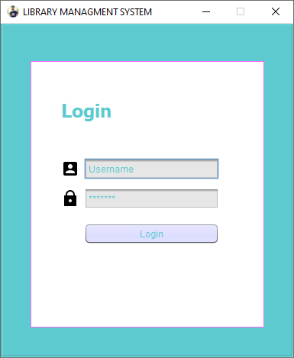

Figure 1.1 Login Form

This is the login page for librarian and admin. The form is designed without colorful
interface because it is used by librarian and admin which can be considered as backend. The login interface is simply design with ID and password textbox.

Main Page

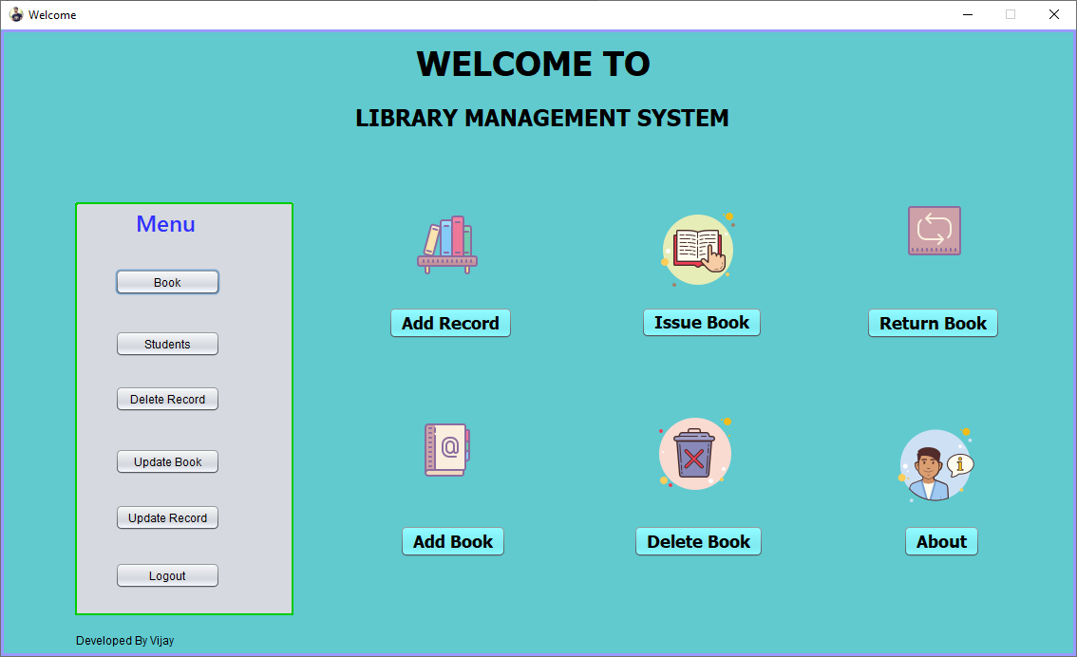

Figure 1.2 Library System Main Form

Figure 1.2 is the main page for library system. In is the form where book transaction
module was carried out. The top you will see title and in the middle all menu items. In this form, the color and word is default setting by NetBeans. There is no
necessary to design the form colorful because Student didn’t make use of this system.

Add Student
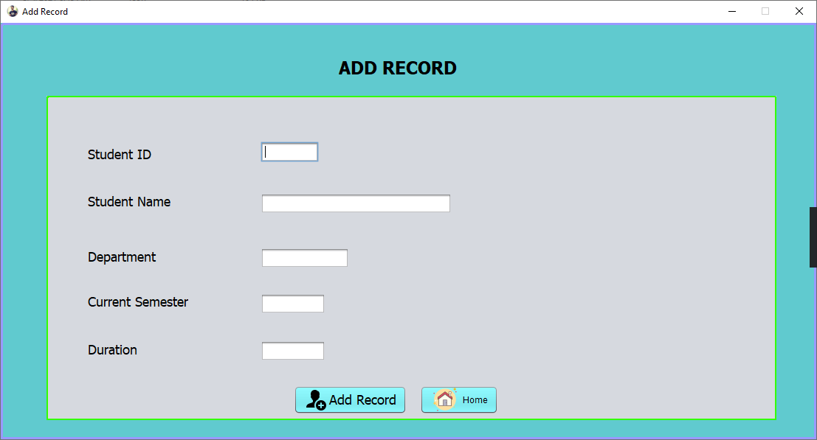

Figure 1.3 Add Student Form
In this form you will enter and save all the information of student.

Add Book
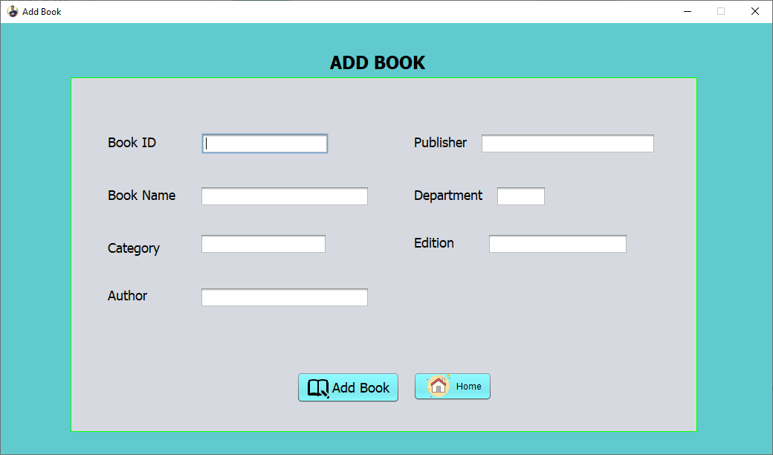

Figure 1.4 Add Book

In this add book form all book information enter and save into database.

Issue Book
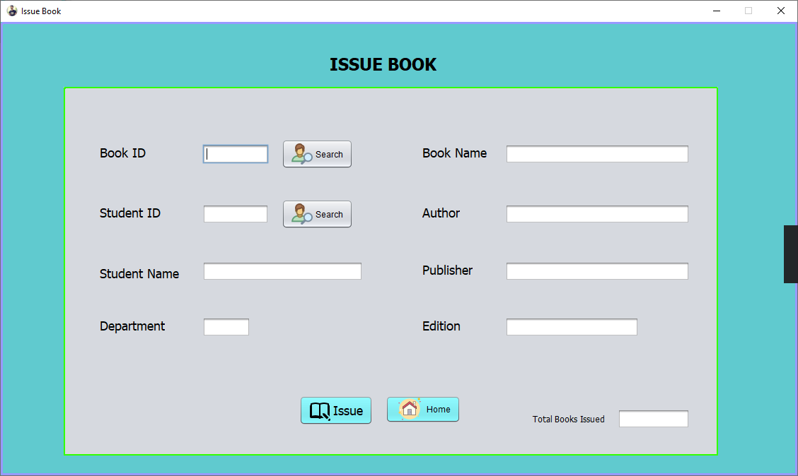

Figure 1.5 Issue Book Form

This is issue book form, for issue book to student firstly librarian have enter Book ID for search the book then enter Student ID to search student record then final;y click on issue book button. And a particular book issued to student.

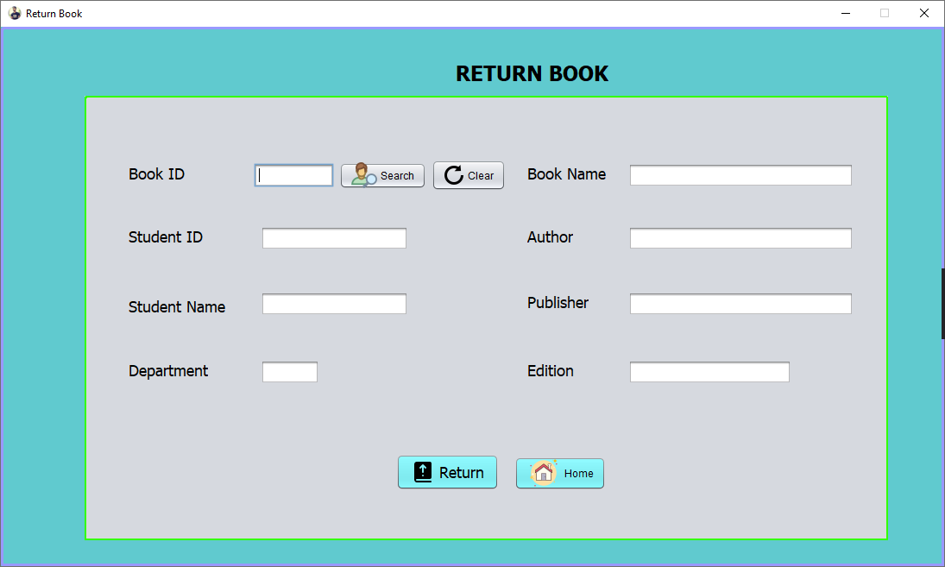
Return Book

Figure 1.6 Return Book Form

This is return book form, interface of this form is very user friendly, for return book there are only have to enter Book id and student id, after that click on return book button.

Student Maintenance Form

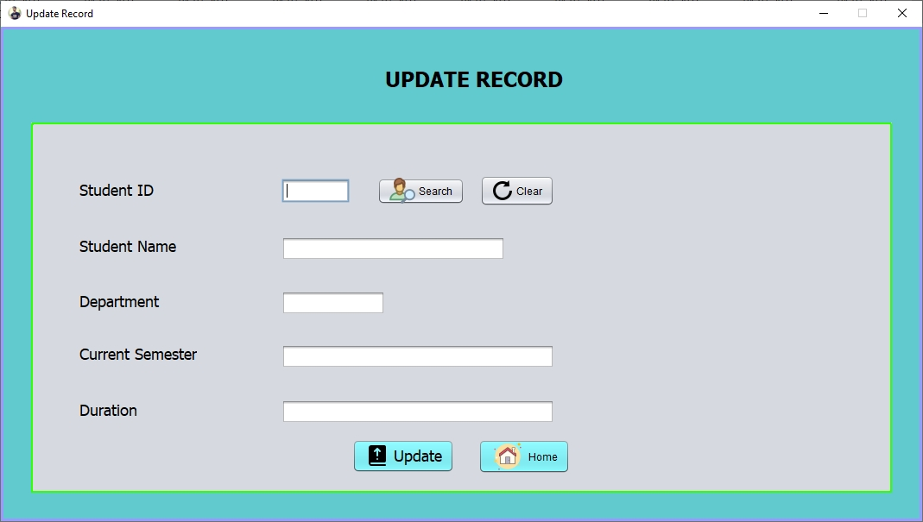

Figure 1.7 Update Form

This is the form for member maintenance. It is almost similar to book maintenance form. The developer put the listview at left side so that user can view the information at right side. It is more users friendly.

There are few functions can be done in member maintenance such as edit
member information. And search student.

Book Maintenance Form

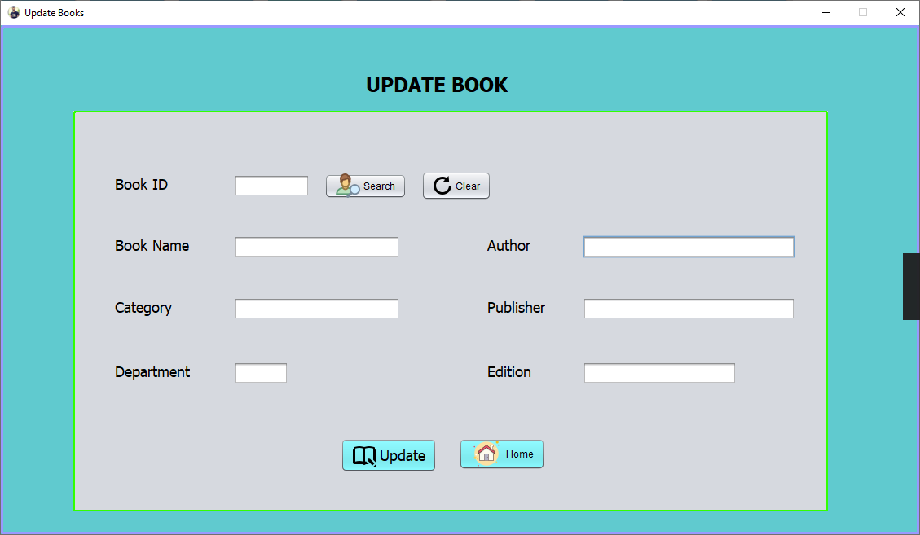

Figure 1.8 Book update form

This is the form for Book maintenance. It is almost similar to Student maintenance form. The developer put the listview at left side so that user can view the information at right side. It is more users friendly.

There are few functions can be done in book maintenance such as edit
Book information. And search particular book.

Delete Book
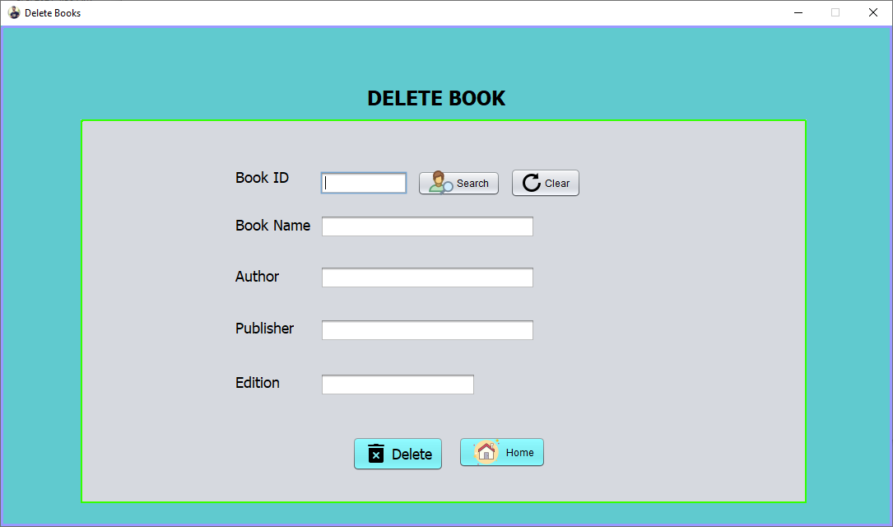

Figure 1.9 Delete Book Form

This is the form for Delete book. It is almost similar to delete record form.
The developer put the listview at left side so that user can view the information at right side. It is more users friendly. There are few functions can be done in search book and delete book.

Delete Record
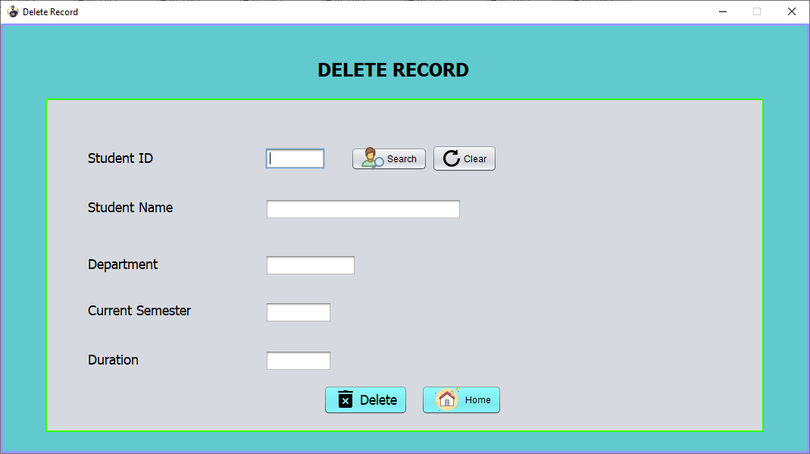

Figure 1.10 Delete Record Form

This is the form for Delete record. It is almost similar to delete book form.
The developer put the listview at left side so that user can view the information at right side. It is more users friendly.
There are few functions can be done in search student record and delete student record.

Search and view Students record

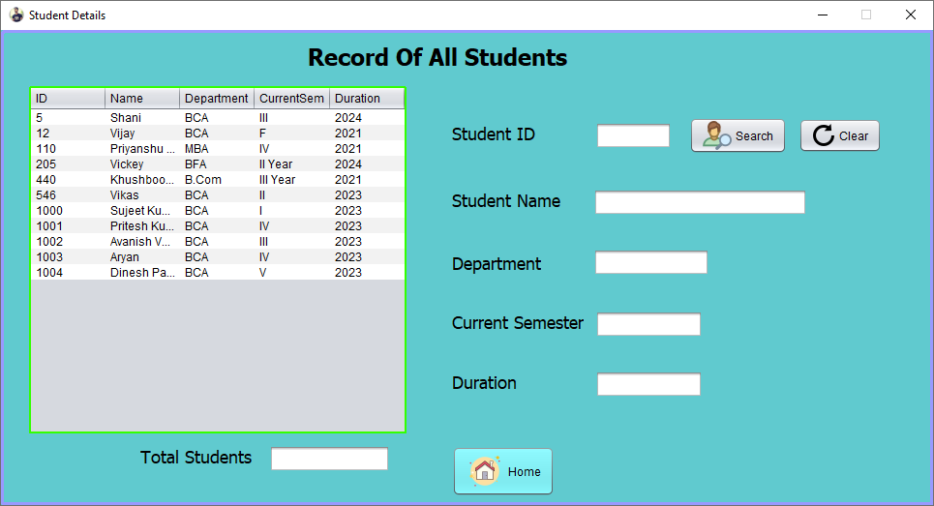

Figure 1.11 Search and view record form

This is the form for search and view all record of students. It is almost similar to search and view book form.
The developer put the listview at left side so that user can view the information at right side. It is more users friendly. There are few functions can be done in search student record.

Search and view books record
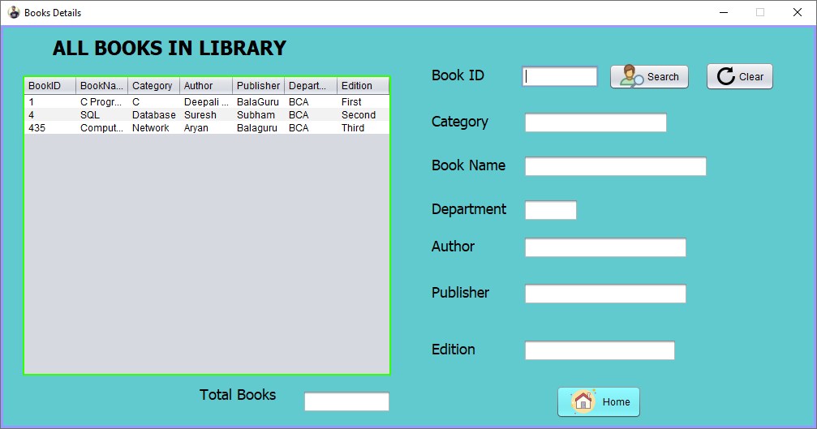

Figure 1.12 Search and view books record form

This is the form for search and view all record of books. It is almost similar to search and view student form. The developer put the listview at left side so that user can view the information at right side.It is more users friendly. There are few functions can be done in search book record.

About Page
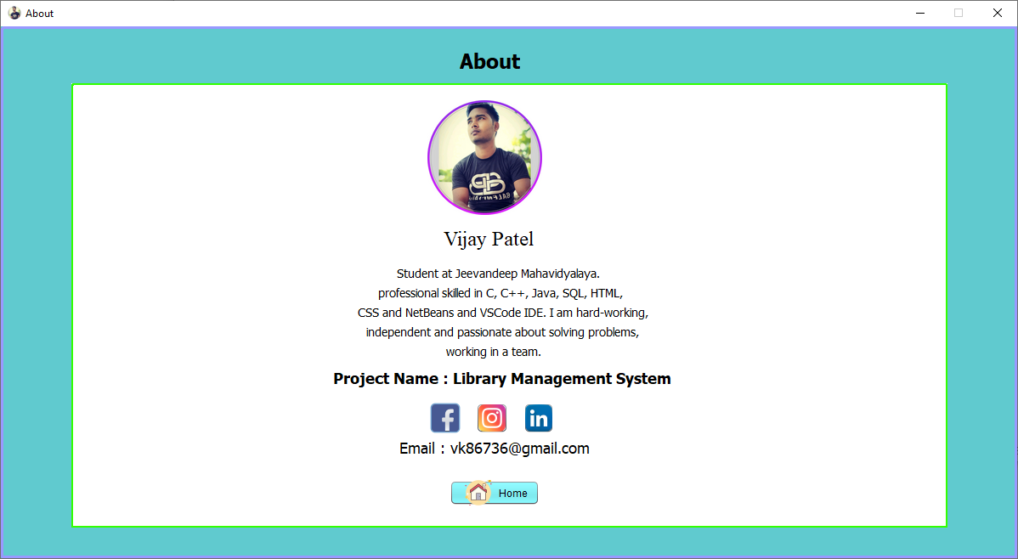

Figure 1.13 About Page

3.1.2 Hardware Interfaces
For Library Management System, no the additional device needed ie. Barcode
scanner is . This can be time saving.

3.1.3 Software Interfaces
Library Management System requires user to install NetBeans IDE. Sqlite
Manager is the latest version of SQL Server and it has been enhanced
compared to SQL Server 2005. For operating system, Library System
requires Window 7 or newer version.

3.1.4 Communication Interfaces
Although Library System is not a web application, but some function
required the internet connection. Thus, HyperText Transfer Protocol (HTTP)
shall be used to provide internet connection to the system. HTTP is a
standard method of transferring data between web server and web client.
Our library system will serves as web client and send the request to targeted
web server.

3.2 Entity Relationship Diagram (ERD)

3.3 Normalization

3.3.1 1st Normalization

StudentInfo (StudentID, StudentName, Department, CurrentSemester, Duration)

IssueBook( BookID, StudentID, StudentName, Department, BookName, Author, Publisher, Edition)

ReturnBook( BookId, StudentID, StudentName, Department, BookName, Author, Publisher, Edition)

DeleteBook( BookID, BookName, Author, Publisher, Edition)

DeleteRecord( StudentID, StudentName, Department, CurrentSem, Duration)

UpdateBook( BookID, BookName, Category, Department, Author, Publisher, Edition)

UpdateRecord( StudentID, StudentName, Department, CurrrentSem, Duration)

3.3.1 2nd Normalization

StudentInfo (StudentID, StudentName, Department, CurrentSemester, Duration)

IssueBook( BookID, StudentID, StudentName, Department, BookName, Author, Publisher, Edition)

ReturnBook( BookId, StudentID, StudentName, Department, BookName, Author, Publisher, Edition)

DeleteBook( BookID, BookName, Author, Publisher, Edition)

DeleteRecord( StudentID, StudentName, Department, CurrentSem, Duration)

UpdateBook( BookID, BookName, Category, Department, Author, Publisher, Edition)

UpdateRecord( StudentID, StudentName, Department, CurrrentSem, Duration)

3.3.1 3rd Normalization

StudentInfo (StudentID, StudentName, Department, CurrentSemester, Duration)

IssueBook( BookID, StudentID, StudentName, Department, BookName, Author, Publisher, Edition)

ReturnBook( BookId, StudentID, StudentName, Department, BookName, Author, Publisher, Edition)

DeleteBook( BookID, BookName, Author, Publisher, Edition)

DeleteRecord( StudentID, StudentName, Department, CurrentSem, Duration)

UpdateBook( BookID, BookName, Category, Department, Author, Publisher, Edition)

UpdateRecord( StudentID, StudentName, Department, CurrrentSem, Duration)

3.4 Data Dictionary

Table 1: AddRecord
Description : Store all information of student
Fields | Data Type | Null/NotNull | Default Value | Rules
StudentId | int | Not null | - | -
StudentName | varchar(50) | Not null | - | -
Department | varchar(50) | Not null | - | -
CurrentSem | varchar(50) | Not null | - | -
Duration | int | Not null | - | -

Fields | Example Data
StudentID | 1000
StudentName | Vijay Kumar Patel
Department | BCA
CurrentSem | V
Duration | 2021

Table 1 Data Dictionary for AddRecord table

Table 2: AddRecord
Description : Store all information of book
Fields | Data Type | Null/NotNull | Default Value | Rules
BookId | int | Not null | - | -
BookName | varchar(50) | Not null | - | -
Category | varchar(50) | Not null | - | -
Author | varchar(50) | Not null | - | -
Publisher | varchar(50) | Not null | - | -
Department | varchar(50) | Not null | - | -
Edition | varchar(50) | Not null | - | -

Fields | Example Data
BookId | 100
BookName | C programming
Category | Programming
Author | Deepali Shrivastva
Publisher | Balaguru
Department | BCA
Edition | First

Table 1 Data Dictionary for AddRecord table

3.5 Chapter 3 Conclusion

In Chapter 3 System Design, we had done about user interface design, database design, normalization and Entity Relationship Diagram.

Due to the user of library system is staff and admin staff, the interface does not need to colorful but need to maintain the user friendliness. The interface designed is using system default color. The button also designed in suitable size so that the interface won’t be messy. Suitable control has been used to ensure users can easily using the library system.

One of the problems I meet in interface design is the report interface. I don’t know how to design a common report which can be used by most of the library. With the aids from my supervisor, I design one more form to let user key in the library detail. The library detail will be used as report header. In this way, every library who used our library system can print the report with different library details.

Next, I meet a big problem when doing normalization. This is because we have already designed the database before doing the documentation. The database we designed is actually a 3rd normalization form. Thus, we need to de-normalize the database back to 1st normalization format. Besides that, I have forgotten how to do the normalization because normalization is learning during Diploma level study. I find back the study material for Database Management subject and refer how to normalize the database.

After completed this chapter, the lesson I learn is we must design a good user interface for the system. It is because the system is used for ease human work. If the user interface is not

users friendly, user can’t enjoy the benefits of the system and they will not likely to use the system. Thus, we must learn how to design a good user interface to bring the maximize benefits to users.

Chapter 4
Prgramming

4.0 Programming
This chapter will discuss about the programming coding of the Library Management
System. Different logic thinking and coding is required at development of the system. A lot,.research has been done to enhance the efficiency when writing coding. Following would discuss the sample programming coding of Java.

4.1 Coding
1. Database Connection

try{
Class.forName("org.sqlite.JDBC");
Connection conn = DriverManager.getConnection("jdbc:sqlite:C:\\Users\\Vijay\\Documents\\NetBeansProjects\\Library_Managment_System\\temp.db");
String sql = "insert into studentdetails (ID,Name,Department,CurrentSem,Duration) values (?,?,?,?,?)";
PreparedStatement pstmt = conn.prepareStatement(sql);
pstmt.setInt(1,Integer.parseInt(FieldStudentId.getText()));
pstmt.setString(2,FieldStudentName.getText());
pstmt.setString(3,FieldDepartment.getText());
pstmt.setString(4,FieldCurrentYear.getText());
pstmt.setString(5,FieldDuration.getText());
pstmt.executeUpdate();
JOptionPane.showMessageDialog(null,"Record Inserted Successfully");
FieldStudentId.setText("");
FieldStudentName.setText("");
FieldDepartment.setText("");
FieldCurrentYear.setText("");
FieldDuration.setText("");
FieldStudentId.requestFocus();
conn.close();

}catch(Exception e){
JOptionPane.showMessageDialog(null,e);
}

Coding above is the connection string declared in Sqlite. It can be used by other
forms after it is declared. . The main advantage of this code is we only change at Sqlite Manager if we change the database.

Login

package Classes;

import java.awt.Toolkit;
import javax.swing.JFrame;
import javax.swing.JOptionPane;

/**
*
* @author Vijay Patel
*/
public class Login extends javax.swing.JFrame {

/**
* Creates new form Login
*/
public Login() {
initComponents();

setExtendedState(JFrame.MAXIMIZED_HORIZ);
setVisible(true);
setResizable(false);

setIconImage();
}
private void ButtonLoginActionPerformed(java.awt.event.ActionEvent evt) {
// TODO add your handling code here:
String Username = UsernameField.getText();
String Pass = PasswordField.getText();

if(Username.equals("Vijay")&& Pass.equals("123"))
{
Main m = new Main();
this.hide();
m.setVisible(true);
}
else
{
JOptionPane.showMessageDialog(this, "Username or Password Do Not Match");
UsernameField.setText("");
PasswordField.setText("");
UsernameField.requestFocus();
}
}

private void UsernameFieldMouseClicked(java.awt.event.MouseEvent evt) {
// TODO add your handling code here:
UsernameField.setText("");
}

private void PasswordFieldMouseClicked(java.awt.event.MouseEvent evt) {
// TODO add your handling code here:
PasswordField.setText("");
}

public static void main(String args[]) {
/* Create and display the form */
java.awt.EventQueue.invokeLater(new Runnable() {
public void run() {
new Login().setVisible(true);
}
});
}

// Variables declaration - do not modify
private javax.swing.JButton ButtonLogin;
private javax.swing.JLabel LabelLogin;
private javax.swing.JPasswordField PasswordField;
private javax.swing.JLabel PasswordIcon;
private javax.swing.JLabel UserIcon;
private javax.swing.JTextField UsernameField;
private javax.swing.JPanel bgPanel;
private javax.swing.JPanel bgPanel1;
// End of variables declaration

private void setIconImage() {
setIconImage(Toolkit.getDefaultToolkit().getImage(getClass().getResource("winicon.png")));
}
}

Figure 1 Login Form

This is login form. Librarian must have enter username and passsword to login into library management system, In the first box there are username must be enter and second box is password box. After enter both username and password, click on login button to enter library management system.

Main Page

package Classes;
import java.awt.Color;
import java.awt.Toolkit;
import javax.swing.JFrame;
import javax.swing.JoptionPane;

/**
*
* @author Vijay
*/

public class Main extends javax.swing.JFrame {

/**
* Creates new form NewJFrame
*/
public Main() {
initComponents();
setExtendedState(JFrame.MAXIMIZED_HORIZ);
setVisible(true);
setResizable(false);
setIconImage();
}

private void ButtonAboutActionPerformed(java.awt.event.ActionEvent evt) {
// TODO add your handling code here:
About m = new About();
this.hide();
m.setVisible(true);
JOptionPane.showMessageDialog(null,"Welcome User ! ");
}

private void ButtonDeleteBookActionPerformed(java.awt.event.ActionEvent evt) {
// TODO add your handling code here:
DeleteBook m = new DeleteBook();
this.hide();
m.setVisible(true);
}

private void ButtonAddBookActionPerformed(java.awt.event.ActionEvent evt) {
// TODO add your handling code here:
AddBook m= new AddBook();
this.hide();

m.setVisible(true);
}

private void ButtonReturnBookActionPerformed(java.awt.event.ActionEvent evt) {
// TODO add your handling code here:
ReturnBook m = new ReturnBook();
this.hide();
m.setVisible(true);
}

private void ButtonIssueBookActionPerformed(java.awt.event.ActionEvent evt) {
// TODO add your handling code here:
IssueBook m = new IssueBook();
this.hide();
m.setVisible(true);
}

private void ButtonAddRecordActionPerformed(java.awt.event.ActionEvent evt) {
// TODO add your handling code here:
AddRecord m = new AddRecord();
this.hide();
m.setVisible(true);
}

private void LogoutButtonActionPerformed(java.awt.event.ActionEvent evt) {
// TODO add your handling code here:
Login m = new Login();
this.hide();
m.setVisible(true);
}

private void IssueButtonActionPerformed(java.awt.event.ActionEvent evt) {

// TODO add your handling code here:
UpdateBook m = new UpdateBook();
this.hide();
m.setVisible(true);
}

private void BookButtonActionPerformed(java.awt.event.ActionEvent evt) {
// TODO add your handling code here:
Book m = new Book();
this.hide();
m.setVisible(true);
}

private void MemberButtonActionPerformed(java.awt.event.ActionEvent evt) {
// TODO add your handling code here:
Student m = new Student();
this.hide();
m.setVisible(true);
}

private void DeleteBookButtonActionPerformed(java.awt.event.ActionEvent evt) {
// TODO add your handling code here:
DeleteRecord m = new DeleteRecord();
this.hide();
m.setVisible(true);
}

private void ReturnButtonActionPerformed(java.awt.event.ActionEvent evt) {
// TODO add your handling code here:
UpdateRecord m = new UpdateRecord();
this.hide();
m.setVisible(true);

}

private void IssuedBookActionPerformed(java.awt.event.ActionEvent evt) {
IssuedBooks m = new IssuedBooks();
this.hide();
m.setVisible(true);
}

public static void main(String args[]) {

java.awt.EventQueue.invokeLater(new Runnable() {
public void run() {
new Main().setVisible(true);
}
});
}

// Variables declaration - do not modify
private javax.swing.JLabel About;
private javax.swing.JLabel AddBook;
private javax.swing.JLabel AddRecord;
private javax.swing.JPanel BgPanel;
private javax.swing.JButton BookButton;
private javax.swing.JButton ButtonAbout;
private javax.swing.JButton ButtonAddBook;
private javax.swing.JButton ButtonAddRecord;
private javax.swing.JButton ButtonDeleteBook;
private javax.swing.JButton ButtonIssueBook;
private javax.swing.JButton ButtonReturnBook;
private javax.swing.JLabel CopyrightLabel;
private javax.swing.JButton DeleteBookButton;
private javax.swing.JLabel DeleteRecord;

private javax.swing.JLabel IssueBook;
private javax.swing.JButton IssueButton;
private javax.swing.JButton IssuedBook;
private javax.swing.JLabel LabelHeading;
private javax.swing.JLabel LabelHeading1;
private javax.swing.JLabel LabelMenu;
private javax.swing.JButton LogoutButton;
private javax.swing.JButton MemberButton;
private javax.swing.JPanel MenuPanel;
private javax.swing.JLabel ReturnBook;
private javax.swing.JButton ReturnButton;
// End of variables declaration

private void setIconImage() {
setIconImage(Toolkit.getDefaultToolkit().getImage(getClass().getResource("winicon.png")));
}
}

Figure 2 Main page

This is the main page of Library management system. All function availble here like librarian can add record, add book, issue book, return book, delete book, delete record, and there are search and view information fuction availble.

Add Record

package Classes;
import java.awt.Toolkit;
import javax.swing.JFrame;
import java.sql.*;
import javax.swing.JOptionPane;

/**
*
* @author Vijay Patel
*/
public class AddRecord extends javax.swing.JFrame {

/**
* Creates new form AddRecord
*/
public AddRecord() {
initComponents();
setExtendedState(JFrame.MAXIMIZED_HORIZ);
setVisible(true);
setResizable(false);
setIconImage();
}

private void HomeButtonActionPerformed(java.awt.event.ActionEvent evt) {
// TODO add your handling code here:

Main m = new Main();
this.hide();
m.setVisible(true);
}

private void AddRecordButtonActionPerformed(java.awt.event.ActionEvent evt) {
try{
Class.forName("org.sqlite.JDBC");
Connection conn = DriverManager.getConnection("jdbc:sqlite:C:\\Users\\Vijay\\Documents\\NetBeansProjects\\Library_Managment_System\\temp.db");
String sql = "insert into studentdetails (ID,Name,Department,CurrentSem,Duration) values (?,?,?,?,?)";
PreparedStatement pstmt = conn.prepareStatement(sql);
pstmt.setInt(1,Integer.parseInt(FieldStudentId.getText()));
pstmt.setString(2,FieldStudentName.getText());
pstmt.setString(3,FieldDepartment.getText());
pstmt.setString(4,FieldCurrentYear.getText());
pstmt.setString(5,FieldDuration.getText());
pstmt.executeUpdate();
JOptionPane.showMessageDialog(null,"Record Inserted Successfully");

FieldStudentId.setText("");
FieldStudentName.setText("");
FieldDepartment.setText("");
FieldCurrentYear.setText("");
FieldDuration.setText("");
FieldStudentId.requestFocus();

conn.close();

}catch(Exception e){
JOptionPane.showMessageDialog(null,e);

}
}

public static void main(String args[]) {

java.awt.EventQueue.invokeLater(() -> {
new AddRecord().setVisible(true);
});
}

// Variables declaration - do not modify
private javax.swing.JButton AddRecordButton;
private javax.swing.JPanel BgPanel;
private javax.swing.JPanel BgPanel1;
private javax.swing.JTextField FieldCurrentYear;
private javax.swing.JTextField FieldDepartment;
private javax.swing.JTextField FieldDuration;
private javax.swing.JTextField FieldStudentId;
private javax.swing.JTextField FieldStudentName;
private javax.swing.JLabel HeadingAddRecord;
private javax.swing.JButton HomeButton;
private javax.swing.JLabel LabelCurrentYear;
private javax.swing.JLabel LabelDepartment;
private javax.swing.JLabel LabelDuration;
private javax.swing.JLabel LabelStudentId;
private javax.swing.JLabel LabelStudentName;
// End of variables declaration

private void setIconImage() {
setIconImage(Toolkit.getDefaultToolkit().getImage(getClass().getResource("winicon.png")));
}

}

Figure 3 Add Student Record Form

This is add student record form, here all student reocrd entered and saved into database.
Threre are some filed that librarian have to enter like student ID, name, department, current sem, duration etc.

Add Book

package Classes;

import java.awt.Toolkit;
import javax.swing.JFrame;
import java.sql.*;
import java.util.logging.Level;
import java.util.logging.Logger;
import javax.swing.JOptionPane;

/**
*
* @author Vijay Patel
*/
public class AddBook extends javax.swing.JFrame {

/**
* Creates new form IssueBook
*/
public AddBook() {
initComponents();
setExtendedState(JFrame.MAXIMIZED_HORIZ);
setVisible(true);
setResizable(false);
setIconImage();
}

private void AddBookButtonActionPerformed(java.awt.event.ActionEvent evt) {
// TODO add your handling code here:
try{
Class.forName("org.sqlite.JDBC");
try (Connection conn = DriverManager.getConnection("jdbc:sqlite:C:\\Users\\Vijay\\Documents\\NetBeansProjects\\Library_Managment_System\\temp.db")) {
String sql = "insert into bookrecord (BookID,BookName,Category,Author,Publisher,Department,Edition) values (?,?,?,?,?,?,?)";
PreparedStatement pstmt = conn.prepareStatement(sql);
pstmt.setInt(1,Integer.parseInt(FieldBookId.getText()));
pstmt.setString(2,FieldBookName.getText());
pstmt.setString(3,FieldCategory.getText());
pstmt.setString(4,FieldBookAuthor.getText());
pstmt.setString(5,FieldBookPublisher.getText());
pstmt.setString(6,FieldDepartment.getText());

pstmt.setString(7,FieldBookEdition.getText());
pstmt.executeUpdate();
JOptionPane.showMessageDialog(this, "Record Inserted");
FieldBookId.setText("");
FieldCategory.setText("");
FieldDepartment.setText("");
FieldBookName.setText("");
FieldBookAuthor.setText("");
FieldBookPublisher.setText("");
FieldBookEdition.setText("");
FieldBookId.requestFocus();
}

}catch(SQLException e)
{
JOptionPane.showMessageDialog(this, "System Error");
} catch (ClassNotFoundException ex) {
Logger.getLogger(AddBook.class.getName()).log(Level.SEVERE, null, ex);
}
}

private void HomeButtonActionPerformed(java.awt.event.ActionEvent evt) {
// TODO add your handling code here:
Main m = new Main();
this.hide();
m.setVisible(true);
}

private void FieldDepartmentActionPerformed(java.awt.event.ActionEvent evt) {
// TODO add your handling code here:
}

/**
* @param args the command line arguments
*/
public static void main(String args[]) {

java.awt.EventQueue.invokeLater(new Runnable() {
public void run() {
new AddBook().setVisible(true);
}
});
}

// Variables declaration - do not modify
private javax.swing.JButton AddBookButton;
private javax.swing.JTextField FieldBookAuthor;
private javax.swing.JTextField FieldBookEdition;
private javax.swing.JTextField FieldBookId;
private javax.swing.JTextField FieldBookName;
private javax.swing.JTextField FieldBookPublisher;
private javax.swing.JTextField FieldCategory;
private javax.swing.JTextField FieldDepartment;
private javax.swing.JLabel HeadingAddBook;
private javax.swing.JButton HomeButton;
private javax.swing.JLabel LabelBookAuthor;
private javax.swing.JLabel LabelBookEdition;
private javax.swing.JLabel LabelBookId;
private javax.swing.JLabel LabelBookName;
private javax.swing.JLabel LabelBookPublisher;
private javax.swing.JLabel LabelCategory;
private javax.swing.JLabel LabelDepartment;
private javax.swing.JPanel bgPanel;
private javax.swing.JPanel bgPanel1;

// End of variables declaration

private void setIconImage() {
setIconImage(Toolkit.getDefaultToolkit().getImage(getClass().getResource("winicon.png")));
}
}

Figure 4 Add Book Form

This is add book form, Here librarian can save books information like BookId, book name, Catogery, Author, Publisher, Department, Edition. After filled these information, click on add book button then information releted to book will save in database.

Issue Book

package Classes;

import java.awt.HeadlessException;
import java.awt.Toolkit;
import javax.swing.JFrame;

import java.sql.*;
import java.util.logging.Level;
import java.util.logging.Logger;
import javax.swing.JOptionPane;

/**
*
* @author Vijay Patel
*/
public class IssueBook extends javax.swing.JFrame {

/**
* Creates new form IssueBook
*/
public IssueBook() {
initComponents();
setExtendedState(JFrame.MAXIMIZED_HORIZ);
setVisible(true);
setResizable(false);
setIconImage();
}

private void HomeButtonActionPerformed(java.awt.event.ActionEvent evt) {
// TODO add your handling code here:
Main m = new Main();
this.hide();
m.setVisible(true);
}

private void IssueButtonActionPerformed(java.awt.event.ActionEvent evt) {
// TODO add your handling code here:
try{

Class.forName("org.sqlite.JDBC");
try (Connection conn = DriverManager.getConnection("jdbc:sqlite:C:\\Users\\Vijay\\Documents\\NetBeansProjects\\Library_Managment_System\\temp.db")) {
String sql = "insert into issuebook (BookID,StudentID,StudentName,Department,BookName,Author,Publisher,Edition) values (?,?,?,?,?,?,?,?)";
PreparedStatement pstmt = conn.prepareStatement(sql);
pstmt.setInt(1,Integer.parseInt(FieldBookId.getText()));
pstmt.setInt(2,Integer.parseInt(FieldStudentId.getText()));
pstmt.setString(3,FieldStudentName.getText());
pstmt.setString(4,FieldDepartment.getText());
pstmt.setString(5,FieldBookName.getText());
pstmt.setString(6,FieldBookAuthor.getText());
pstmt.setString(7,FieldBookPublisher.getText());
pstmt.setString(8,FieldBookEdition.getText());
pstmt.executeUpdate();
JOptionPane.showMessageDialog(this,"Book With ID = "+FieldBookId.getText()+" Has Been Issued To "+FieldStudentName.getText()+", Successfully ");
FieldBookId.setText("");
FieldStudentId.setText("");
FieldDepartment.setText("");
FieldDepartment.setText("");
FieldBookName.setText("");
FieldBookAuthor.setText("");
FieldBookPublisher.setText("");
FieldBookEdition.setText("");
FieldBookId.requestFocus();
}

}catch(SQLException e)
{
if(e.getErrorCode()==1062)

JOptionPane.showMessageDialog(this,"This Book is Taken By Someone, A Student Can Only Get A Single Book From Library At A Time ");
} catch (ClassNotFoundException ex) {
Logger.getLogger(AddBook.class.getName()).log(Level.SEVERE, null, ex);
}
}

private void SearchButtonActionPerformed(java.awt.event.ActionEvent evt) {
// TODO add your handling code here:
try{
Class.forName("org.sqlite.JDBC");
Connection conn = DriverManager.getConnection("jdbc:sqlite:C:\\Users\\Vijay\\Documents\\NetBeansProjects\\Library_Managment_System\\temp.db");

String sql = "select *from bookrecord where BookID = ?";
PreparedStatement pstmt = conn.prepareStatement(sql);
pstmt.setInt(1,Integer.parseInt(FieldBookId.getText()));

ResultSet rs = pstmt.executeQuery();
if(rs.next()){
FieldBookName.setText(rs.getString("BookName"));
FieldDepartment.setText(rs.getString("Department"));
FieldBookAuthor.setText(rs.getString("Author"));
FieldBookPublisher.setText(rs.getString("Publisher"));
FieldBookEdition.setText(rs.getString("Edition"));
}
else{

JOptionPane.showMessageDialog(null,"Record Not Found");
}
conn.close();

}catch(HeadlessException | ClassNotFoundException | NumberFormatException | SQLException e){
JOptionPane.showMessageDialog(null,e);
}
}

private void SearchButton2ActionPerformed(java.awt.event.ActionEvent evt) {
// TODO add your handling code here:
try{
Class.forName("org.sqlite.JDBC");
Connection conn = DriverManager.getConnection("jdbc:sqlite:C:\\Users\\Vijay\\Documents\\NetBeansProjects\\Library_Managment_System\\temp.db");

String sql = "select *from studentdetails where ID = ?";
PreparedStatement pstmt = conn.prepareStatement(sql);
pstmt.setInt(1,Integer.parseInt(FieldStudentId.getText()));
ResultSet rs = pstmt.executeQuery();
if(rs.next()){
FieldStudentName.setText(rs.getString("Name"));
}
else{
JOptionPane.showMessageDialog(null,"Record Not Found");
}
conn.close();
}catch(Exception e){
JOptionPane.showMessageDialog(null,e);
}
}

/**
* @param args the command line arguments
*/

public static void main(String args[]) {

java.awt.EventQueue.invokeLater(new Runnable() {
public void run() {
new IssueBook().setVisible(true);
}
});
}

// Variables declaration - do not modify
private javax.swing.JTextField FieldBookAuthor;
private javax.swing.JTextField FieldBookEdition;
private javax.swing.JTextField FieldBookEdition1;
private javax.swing.JTextField FieldBookId;
private javax.swing.JTextField FieldBookName;
private javax.swing.JTextField FieldBookPublisher;
private javax.swing.JTextField FieldDepartment;
private javax.swing.JTextField FieldStudentId;
private javax.swing.JTextField FieldStudentName;
private javax.swing.JLabel HeadingIssueBook;
private javax.swing.JButton HomeButton;
private javax.swing.JButton IssueButton;
private javax.swing.JLabel LabelBookAuthor;
private javax.swing.JLabel LabelBookAuthor1;
private javax.swing.JLabel LabelBookEdition;
private javax.swing.JLabel LabelBookId;
private javax.swing.JLabel LabelBookName;
private javax.swing.JLabel LabelBookPublisher;
private javax.swing.JLabel LabelDepartment;
private javax.swing.JLabel LabelStudentId;
private javax.swing.JLabel LabelStudentName;
private javax.swing.JButton SearchButton;

private javax.swing.JButton SearchButton2;
private javax.swing.JPanel bgPanel;
private javax.swing.JPanel bgPanel1;
// End of variables declaration

private void setIconImage() {
setIconImage(Toolkit.getDefaultToolkit().getImage(getClass().getResource("winicon.png")));
}
}

Figure 5 Issue Book Form
For issue book to student ,there are a form for book issue, In this form information will fill like Bookid, student id, student name, department, book name, author, publisher, and edition.
But there are search functionality provide so librarian have only enter bookid and student id then click in search and all information releted automatically filled in all boxes.

Return Book

package Classes;

import java.awt.Toolkit;
import javax.swing.JFrame;
import java.sql.*;
import javax.swing.JOptionPane;

/**
*
* @author Vijay Patel
*/
public class ReturnBook extends javax.swing.JFrame {

/**
* Creates new form IssueBook
*/
public ReturnBook() {
initComponents();
setExtendedState(JFrame.MAXIMIZED_HORIZ);
setVisible(true);
setResizable(false);
setIconImage();
}

private void ReturnButtonActionPerformed(java.awt.event.ActionEvent evt) {
// TODO add your handling code here:
try{
Class.forName("org.sqlite.JDBC");
Connection conn = DriverManager.getConnection("jdbc:sqlite:C:\\Users\\Vijay\\Documents\\NetBeansProjects\\Library_Managment_System\\temp.db");

String sql = "delete from issuebook where BookID = ?";
PreparedStatement pstmt = conn.prepareStatement(sql);
pstmt.setInt(1,Integer.parseInt(FieldBookId.getText()));
pstmt.executeUpdate();
JOptionPane.showMessageDialog(this,"Book With ID = "+FieldBookId.getText()+" Has Been Returned From "+FieldStudentName.getText()+", Successfully ");

FieldBookId.setText("");
FieldBookName.setText("");
FieldStudentName.setText("");
FieldDepartment.setText("");
FieldStudentId.setText("");
FieldBookAuthor.setText("");
FieldBookPublisher.setText("");
FieldBookEdition.setText("");
FieldBookId.requestFocus();

conn.close();

}catch(Exception e){
JOptionPane.showMessageDialog(null,e);
}
}

private void HomeButtonActionPerformed(java.awt.event.ActionEvent evt) {
// TODO add your handling code here:
Main m = new Main();
this.hide();
m.setVisible(true);
}

private void SearchButtonActionPerformed(java.awt.event.ActionEvent evt) {

// TODO add your handling code here:
try{
Class.forName("org.sqlite.JDBC");
Connection conn = DriverManager.getConnection("jdbc:sqlite:C:\\Users\\Vijay\\Documents\\NetBeansProjects\\Library_Managment_System\\temp.db");

String sql = "select *from issuebook where BookID = ?";
PreparedStatement pstmt = conn.prepareStatement(sql);
pstmt.setInt(1,Integer.parseInt(FieldBookId.getText()));
ResultSet rs = pstmt.executeQuery();
if(rs.next()){
FieldBookName.setText(rs.getString("BookName"));
FieldStudentName.setText(rs.getString("StudentName"));
FieldStudentId.setText(rs.getString("StudentID"));
FieldDepartment.setText(rs.getString("Department"));
FieldBookAuthor.setText(rs.getString("Author"));
FieldBookPublisher.setText(rs.getString("Publisher"));
FieldBookEdition.setText(rs.getString("Edition"));
}
else{
JOptionPane.showMessageDialog(null,"Record Not Found");
}
conn.close();
}catch(Exception e){
JOptionPane.showMessageDialog(null,e);
}
}

private void ClearButtonActionPerformed(java.awt.event.ActionEvent evt) {
// TODO add your handling code here:
FieldBookId.setText("");
FieldBookName.setText("");

FieldStudentName.setText("");
FieldDepartment.setText("");
FieldStudentId.setText("");
FieldBookAuthor.setText("");
FieldBookPublisher.setText("");
FieldBookEdition.setText("");
FieldBookId.requestFocus();
}

private void SearchStudentActionPerformed(java.awt.event.ActionEvent evt) {
// TODO add your handling code here:
try{
Class.forName("org.sqlite.JDBC");
Connection conn = DriverManager.getConnection("jdbc:sqlite:C:\\Users\\Vijay\\Documents\\NetBeansProjects\\Library_Managment_System\\temp.db");

String sql = "select *from studentdetails where ID = ?";
PreparedStatement pstmt = conn.prepareStatement(sql);
pstmt.setInt(1,Integer.parseInt(FieldStudentId.getText()));
ResultSet rs = pstmt.executeQuery();
if(rs.next()){
FieldStudentName.setText(rs.getString("Name"));
}
else{
JOptionPane.showMessageDialog(null,"Record Not Found");
}
conn.close();
}catch(Exception e){
JOptionPane.showMessageDialog(null,e);
}
}

/**
* @param args the command line arguments
*/
public static void main(String args[]) {

java.awt.EventQueue.invokeLater(new Runnable() {
public void run() {
new ReturnBook().setVisible(true);
}
});
}

// Variables declaration - do not modify
private javax.swing.JButton ClearButton;
private javax.swing.JTextField FieldBookAuthor;
private javax.swing.JTextField FieldBookEdition;
private javax.swing.JTextField FieldBookId;
private javax.swing.JTextField FieldBookName;
private javax.swing.JTextField FieldBookPublisher;
private javax.swing.JTextField FieldDepartment;
private javax.swing.JTextField FieldStudentId;
private javax.swing.JTextField FieldStudentName;
private javax.swing.JLabel HeadingReturnBook;
private javax.swing.JButton HomeButton;
private javax.swing.JLabel LabelBookAuthor;
private javax.swing.JLabel LabelBookEdition;
private javax.swing.JLabel LabelBookId;
private javax.swing.JLabel LabelBookName;
private javax.swing.JLabel LabelBookPublisher;
private javax.swing.JLabel LabelDepartment;
private javax.swing.JLabel LabelStudentId;
private javax.swing.JLabel LabelStudentName;

private javax.swing.JButton ReturnButton;
private javax.swing.JButton SearchButton;
private javax.swing.JButton SearchStudent;
private javax.swing.JPanel bgPanel;
private javax.swing.JPanel bgPanel1;
// End of variables declaration

private void setIconImage() {
setIconImage(Toolkit.getDefaultToolkit().getImage(getClass().getResource("winicon.png")));
}
}

Figure 6 Return Book Form

For return book, there are return book form availble. In this form on Book id have to enter then click on search button , all information releted automatically filled in all boxes.

Delete Book

package Classes;

import java.awt.Toolkit;
import javax.swing.JFrame;
import java.sql.*;
import javax.swing.JOptionPane;

/**
*
* @author Vijay Patel
*/
public class DeleteBook extends javax.swing.JFrame {

/**
* Creates new form IssueBook
*/
public DeleteBook() {
initComponents();

setExtendedState(JFrame.MAXIMIZED_HORIZ);
setVisible(true);
setResizable(false);
setIconImage();
}

private void DeleteButtonActionPerformed(java.awt.event.ActionEvent evt) {
// TODO add your handling code here:
try{
Class.forName("org.sqlite.JDBC");

Connection conn = DriverManager.getConnection("jdbc:sqlite:C:\\Users\\Vijay\\Documents\\NetBeansProjects\\Library_Managment_System\\temp.db");
String sql = "delete from bookrecord where BookID = ?";
PreparedStatement pstmt = conn.prepareStatement(sql);
pstmt.setInt(1,Integer.parseInt(FieldBookId.getText()));
pstmt.executeUpdate();
JOptionPane.showMessageDialog(this,"Book With ID = "+FieldBookId.getText()+" Has Been Deleted Successfully ");

FieldBookId.setText("");
FieldBookName.setText("");
FieldBookAuthor.setText("");
FieldBookPublisher.setText("");
FieldBookEdition.setText("");
FieldBookId.requestFocus();

conn.close();

}catch(Exception e){
JOptionPane.showMessageDialog(null,e);
}
}

private void HomeButtonActionPerformed(java.awt.event.ActionEvent evt) {
// TODO add your handling code here:
Main m = new Main();
this.hide();
m.setVisible(true);
}

private void SearchButtonActionPerformed(java.awt.event.ActionEvent evt) {
// TODO add your handling code here:

try{
Class.forName("org.sqlite.JDBC");
Connection conn = DriverManager.getConnection("jdbc:sqlite:C:\\Users\\Vijay\\Documents\\NetBeansProjects\\Library_Managment_System\\temp.db");

String sql = "select *from bookrecord where BookID = ?";
PreparedStatement pstmt = conn.prepareStatement(sql);
pstmt.setInt(1,Integer.parseInt(FieldBookId.getText()));
ResultSet rs = pstmt.executeQuery();
if(rs.next()){
FieldBookName.setText(rs.getString("BookName"));
FieldBookAuthor.setText(rs.getString("Author"));
FieldBookPublisher.setText(rs.getString("Publisher"));
FieldBookEdition.setText(rs.getString("Edition"));
}
else{
JOptionPane.showMessageDialog(null,"Record Not Found");
}
conn.close();
}catch(Exception e){
JOptionPane.showMessageDialog(null,e);
}
}

private void ClearButtonActionPerformed(java.awt.event.ActionEvent evt) {
// TODO add your handling code here:
FieldBookId.setText("");
FieldBookName.setText("");
FieldBookAuthor.setText("");
FieldBookPublisher.setText("");
FieldBookEdition.setText("");
FieldBookId.requestFocus();

}

/**
* @param args the command line arguments
*/
public static void main(String args[]) {

java.awt.EventQueue.invokeLater(new Runnable() {
public void run() {
new DeleteBook().setVisible(true);
}
});
}

// Variables declaration - do not modify
private javax.swing.JButton ClearButton;
private javax.swing.JButton DeleteButton;
private javax.swing.JTextField FieldBookAuthor;
private javax.swing.JTextField FieldBookEdition;
private javax.swing.JTextField FieldBookId;
private javax.swing.JTextField FieldBookName;
private javax.swing.JTextField FieldBookPublisher;
private javax.swing.JLabel HeadingDeleteBook;
private javax.swing.JButton HomeButton;
private javax.swing.JLabel LabelBookAuthor;
private javax.swing.JLabel LabelBookEdition;
private javax.swing.JLabel LabelBookId;
private javax.swing.JLabel LabelBookName;
private javax.swing.JLabel LabelBookPublisher;
private javax.swing.JButton SearchButton;
private javax.swing.JPanel bgPanel;
private javax.swing.JPanel bgPanel1;

// End of variables declaration

private void setIconImage() {
setIconImage(Toolkit.getDefaultToolkit().getImage(getClass().getResource("winicon.png")));
}
}

Figure 7 Delete Book Form

This is delete book form for deleting a paticular book from database. Librarian have to enter only book id then click on search, all information releted to given book id automatically filled in all boxes. When click on delete button, book got deleted from database.

Delete Record

package Classes;
import java.awt.Toolkit;
import java.sql.*;
import javax.swing.JFrame;
import javax.swing.JOptionPane;

/**
*
* @author Vijay
*/
public class DeleteRecord extends javax.swing.JFrame {

/**
* Creates new form DeleteRecord
*/
public DeleteRecord() {
initComponents();
setExtendedState(JFrame.MAXIMIZED_HORIZ);
setVisible(true);
setResizable(false);
setIconImage();
}

private void DeleteRecordButtonActionPerformed(java.awt.event.ActionEvent evt) {
// TODO add your handling code here:
try{
Class.forName("org.sqlite.JDBC");
Connection conn = DriverManager.getConnection("jdbc:sqlite:C:\\Users\\Vijay\\Documents\\NetBeansProjects\\Library_Managment_System\\temp.db");
String sql = "delete from studentdetails where ID = ?";

PreparedStatement pstmt = conn.prepareStatement(sql);
pstmt.setInt(1,Integer.parseInt(FieldStudentId.getText()));
pstmt.executeUpdate();
JOptionPane.showMessageDialog(null,"Record Deleted Successfully");

FieldStudentId.setText("");
FieldStudentName.setText("");
FieldDepartment.setText("");
FieldCurrentYear.setText("");
FieldDuration.setText("");
FieldStudentId.requestFocus();

conn.close();

}catch(Exception e){
JOptionPane.showMessageDialog(null,e);
}
}

private void HomeButtonActionPerformed(java.awt.event.ActionEvent evt) {
// TODO add your handling code here:
Main m = new Main();
this.hide();
m.setVisible(true);
}

private void SearchButtonActionPerformed(java.awt.event.ActionEvent evt) {
// TODO add your handling code here:
try{
Class.forName("org.sqlite.JDBC");
Connection conn = DriverManager.getConnection("jdbc:sqlite:C:\\Users\\Vijay\\Documents\\NetBeansProjects\\Library_Managment_System\\temp.db");

String sql = "select *from studentdetails where ID = ?";
PreparedStatement pstmt = conn.prepareStatement(sql);
pstmt.setInt(1,Integer.parseInt(FieldStudentId.getText()));
ResultSet rs = pstmt.executeQuery();
if(rs.next()){
FieldStudentName.setText(rs.getString("Name"));
FieldDepartment.setText(rs.getString("Department"));
FieldCurrentYear.setText(rs.getString("CurrentSem"));
FieldDuration.setText(rs.getString("Duration"));
}
else{
JOptionPane.showMessageDialog(null,"Record Not Found");
}
conn.close();
}catch(Exception e){
JOptionPane.showMessageDialog(null,e);
}
}

private void ClearButtonActionPerformed(java.awt.event.ActionEvent evt) {
// TODO add your handling code here:
FieldStudentId.setText("");
FieldStudentName.setText("");
FieldDepartment.setText("");
FieldCurrentYear.setText("");
FieldDuration.setText("");
FieldStudentId.requestFocus();
}

/**
* @param args the command line arguments
*/

public static void main(String args[]) {

java.awt.EventQueue.invokeLater(() -> {
new DeleteRecord().setVisible(true);
});
}

// Variables declaration - do not modify
private javax.swing.JPanel BgPanel;
private javax.swing.JPanel BgPanel1;
private javax.swing.JButton ClearButton;
private javax.swing.JButton DeleteRecordButton;
private javax.swing.JTextField FieldCurrentYear;
private javax.swing.JTextField FieldDepartment;
private javax.swing.JTextField FieldDuration;
private javax.swing.JTextField FieldStudentId;
private javax.swing.JTextField FieldStudentName;
private javax.swing.JLabel HeadingDeleteRecord;
private javax.swing.JButton HomeButton;
private javax.swing.JLabel LabelCurrentYear;
private javax.swing.JLabel LabelDepartment;
private javax.swing.JLabel LabelDuration;
private javax.swing.JLabel LabelStudentId;
private javax.swing.JLabel LabelStudentName;
private javax.swing.JButton SearchButton;
// End of variables declaration

private void setIconImage() {
setIconImage(Toolkit.getDefaultToolkit().getImage(getClass().getResource("winicon.png")));
}
}

Figure 8 Delete Student Information form

This is delete Student record form for deleting a paticular student record from database. Librarian have to enter only student id then click on search, all information releted to given student id automatically filled in all boxes. When click on delete button, student information got deleted from database.

Update Student Record
package Classes;
import java.awt.HeadlessException;
import java.awt.Toolkit;
import java.sql.*;
import javax.swing.JFrame;
import javax.swing.JOptionPane;

/**
*
* @author Vijay
*/

public class UpdateRecord extends javax.swing.JFrame {

/**
* Creates new form UpdateRecord
*/
public UpdateRecord() {
initComponents();
setExtendedState(JFrame.MAXIMIZED_HORIZ);
setVisible(true);
setResizable(false);
setIconImage();
}

private void UpdateButtonActionPerformed(java.awt.event.ActionEvent evt) {
// TODO add your handling code here:
try{
Class.forName("org.sqlite.JDBC");
try (Connection conn = DriverManager.getConnection("jdbc:sqlite:C:\\Users\\Vijay\\Documents\\NetBeansProjects\\Library_Managment_System\\temp.db")) {
String sql;
sql = "update studentdetails set Name = ?, Department = ?, CurrentSem = ?, Duration = ? where ID = ?";
PreparedStatement pstmt = conn.prepareStatement(sql);
pstmt.setString(1,FieldStudentName.getText());
pstmt.setString(2,FieldDepartment.getText());
pstmt.setString(3,FieldCurrentYear.getText());
pstmt.setInt(4,Integer.parseInt(FieldDuration.getText()));
pstmt.setInt(5,Integer.parseInt(FieldStudentId.getText()));
pstmt.executeUpdate();
JOptionPane.showMessageDialog(null,"Record Update Successfully");
FieldStudentName.setText("");
FieldDepartment.setText("");

FieldCurrentYear.setText("");
FieldDuration.setText("");
FieldStudentId.requestFocus();
}
}catch(HeadlessException | ClassNotFoundException | SQLException e){
JOptionPane.showMessageDialog(null,e);
}
}

private void HomeButtonActionPerformed(java.awt.event.ActionEvent evt) {
// TODO add your handling code here:
Main m = new Main();
this.hide();
m.setVisible(true);
}

private void SearchButtonActionPerformed(java.awt.event.ActionEvent evt) {
// TODO add your handling code here:
try{
Class.forName("org.sqlite.JDBC");
Connection conn = DriverManager.getConnection("jdbc:sqlite:C:\\Users\\Vijay\\Documents\\NetBeansProjects\\Library_Managment_System\\temp.db");

String sql = "select *from studentdetails where ID = ?";
PreparedStatement pstmt = conn.prepareStatement(sql);
pstmt.setInt(1,Integer.parseInt(FieldStudentId.getText()));
ResultSet rs = pstmt.executeQuery();
if(rs.next()){
FieldStudentName.setText(rs.getString("Name"));
FieldDepartment.setText(rs.getString("Department"));
FieldCurrentYear.setText(rs.getString("CurrentSem"));
FieldDuration.setText(rs.getString("Duration"));

}
else{
JOptionPane.showMessageDialog(null,"Record Not Found");
}
conn.close();
}catch(Exception e){
JOptionPane.showMessageDialog(null,e);
}
}

private void ClearButtonActionPerformed(java.awt.event.ActionEvent evt) {
// TODO add your handling code here:
FieldStudentId.setText("");
FieldStudentName.setText("");
FieldDepartment.setText("");
FieldCurrentYear.setText("");
FieldDuration.setText("");
FieldStudentId.requestFocus();
}

/**
* @param args the command line arguments
*/
public static void main(String args[]) {

java.awt.EventQueue.invokeLater(() -> {
new UpdateRecord().setVisible(true);
});
}

// Variables declaration - do not modify
private javax.swing.JPanel BgPanel;

private javax.swing.JPanel BgPanel1;
private javax.swing.JButton ClearButton;
private javax.swing.JTextField FieldCurrentYear;
private javax.swing.JTextField FieldDepartment;
private javax.swing.JTextField FieldDuration;
private javax.swing.JTextField FieldStudentId;
private javax.swing.JTextField FieldStudentName;
private javax.swing.JLabel HeadingUpdateRecord;
private javax.swing.JButton HomeButton;
private javax.swing.JLabel LabelCurrentYear;
private javax.swing.JLabel LabelDepartment;
private javax.swing.JLabel LabelDuration;
private javax.swing.JLabel LabelStudentId;
private javax.swing.JLabel LabelStudentName;
private javax.swing.JButton SearchButton;
private javax.swing.JButton UpdateButton;
// End of variables declaration

private void setIconImage() {
setIconImage(Toolkit.getDefaultToolkit().getImage(getClass().getResource("winicon.png")));
}
}

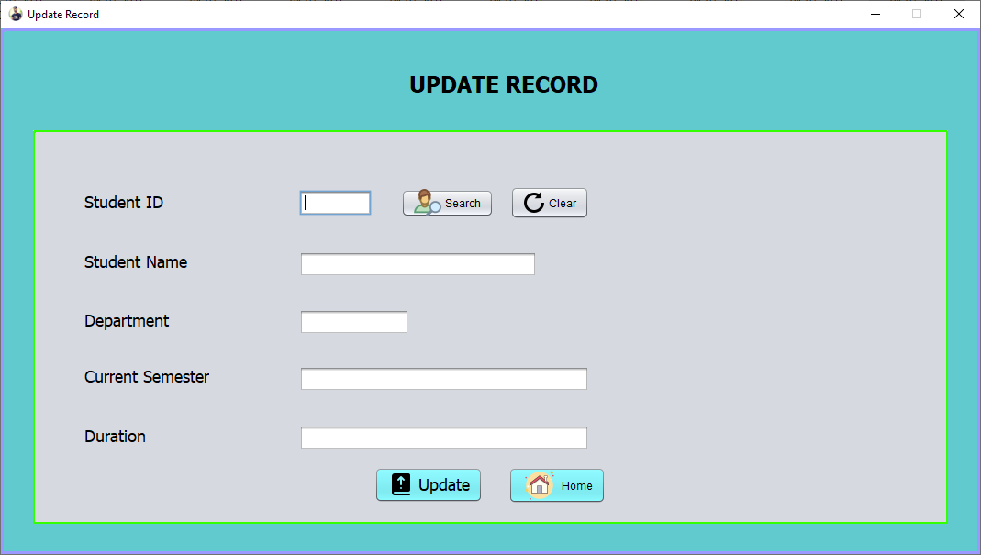

Figure 9 update student record

This form for updating student record. Sometimes worng information filled and saved in database. So for alter those record, there are Update record form availble. Librarian have to enter student id then click on search button, and all information filled in boxes automatically. Then change wrong information and click on update button.

Update Book Information

package Classes;
import java.awt.HeadlessException;
import java.awt.Toolkit;
import java.sql.*;
import javax.swing.JFrame;
import javax.swing.JOptionPane;

/**
*
* @author Vijay

*/
public class UpdateBook extends javax.swing.JFrame {

/**
* Creates new form UpdateBook
*/
public UpdateBook() {
initComponents();
setExtendedState(JFrame.MAXIMIZED_HORIZ);
setVisible(true);
setResizable(false);
setIconImage();
}

private void UpdateButtonActionPerformed(java.awt.event.ActionEvent evt) {
// TODO add your handling code here:
try{
Class.forName("org.sqlite.JDBC");
try (Connection conn = DriverManager.getConnection("jdbc:sqlite:C:\\Users\\Vijay\\Documents\\NetBeansProjects\\Library_Managment_System\\temp.db")) {
String sql;
sql = "update bookrecord set BookName = ?, Category = ?, Author = ?, Publisher = ?, Department = ?, Edition = ? where BookID = ?";
PreparedStatement pstmt = conn.prepareStatement(sql);
pstmt.setString(1,FieldBookName.getText());
pstmt.setString(2,FieldCategory.getText());
pstmt.setString(3,FieldBookAuthor.getText());
pstmt.setString(4,FieldBookPublisher.getText());
pstmt.setString(5,FieldDepartment.getText());
pstmt.setString(6,FieldBookEdition.getText());
pstmt.setInt(7, Integer.parseInt(FieldBookId.getText()));
pstmt.executeUpdate();
JOptionPane.showMessageDialog(null,"Record Update Successfully");

FieldBookName.setText("");
FieldDepartment.setText("");
FieldCategory.setText("");
FieldBookAuthor.setText("");
FieldBookPublisher.setText("");
FieldBookEdition.setText("");
FieldBookId.requestFocus();
conn.close();
}
}catch(HeadlessException | ClassNotFoundException | SQLException e){
JOptionPane.showMessageDialog(null,e);
}
}

private void HomeButtonActionPerformed(java.awt.event.ActionEvent evt) {
// TODO add your handling code here:
Main m = new Main();
this.hide();
m.setVisible(true);
}

private void SearchButtonActionPerformed(java.awt.event.ActionEvent evt) {
// TODO add your handling code here:
try{
Class.forName("org.sqlite.JDBC");
Connection conn = DriverManager.getConnection("jdbc:sqlite:C:\\Users\\Vijay\\Documents\\NetBeansProjects\\Library_Managment_System\\temp.db");

String sql = "select *from bookrecord where BookID = ?";
PreparedStatement pstmt = conn.prepareStatement(sql);
pstmt.setInt(1,Integer.parseInt(FieldBookId.getText()));
ResultSet rs = pstmt.executeQuery();

if(rs.next()){
FieldBookName.setText(rs.getString("BookName"));
FieldCategory.setText(rs.getString("Category"));
FieldDepartment.setText(rs.getString("Department"));
FieldBookAuthor.setText(rs.getString("Author"));
FieldBookPublisher.setText(rs.getString("Publisher"));
FieldBookEdition.setText(rs.getString("Edition"));
}
else{
JOptionPane.showMessageDialog(null,"Record Not Found");
}
conn.close();
}catch(Exception e){
JOptionPane.showMessageDialog(null,e);
}
}

private void ClearButtonActionPerformed(java.awt.event.ActionEvent evt) {
// TODO add your handling code here:
FieldBookId.setText("");
FieldBookName.setText("");
FieldDepartment.setText("");
FieldCategory.setText("");
FieldBookAuthor.setText("");
FieldBookPublisher.setText("");
FieldBookEdition.setText("");
FieldBookId.requestFocus();
}

/**
* @param args the command line arguments
*/

public static void main(String args[]) {

java.awt.EventQueue.invokeLater(() -> {
new UpdateBook().setVisible(true);
});
}

// Variables declaration - do not modify
private javax.swing.JButton ClearButton;
private javax.swing.JTextField FieldBookAuthor;
private javax.swing.JTextField FieldBookEdition;
private javax.swing.JTextField FieldBookId;
private javax.swing.JTextField FieldBookName;
private javax.swing.JTextField FieldBookPublisher;
private javax.swing.JTextField FieldCategory;
private javax.swing.JTextField FieldDepartment;
private javax.swing.JLabel HeadingIssueBook;
private javax.swing.JButton HomeButton;
private javax.swing.JLabel LabelBookAuthor;
private javax.swing.JLabel LabelBookEdition;
private javax.swing.JLabel LabelBookId;
private javax.swing.JLabel LabelBookName;
private javax.swing.JLabel LabelBookPublisher;
private javax.swing.JLabel LabelCategory;
private javax.swing.JLabel LabelDepartment;
private javax.swing.JButton SearchButton;
private javax.swing.JButton UpdateButton;
private javax.swing.JPanel bgPanel;
private javax.swing.JPanel bgPanel1;
// End of variables declaration

private void setIconImage() {

setIconImage(Toolkit.getDefaultToolkit().getImage(getClass().getResource("winicon.png")));
}
}

Figure 10 update book form

This form for updating Book record. Sometimes worng information filled and saved in database. So for alter those record, there are Update book record form availble. Librarian have to enter book id then click on search button, and all information filled in boxes automatically. Then change wrong information and click on update button.

All Books

package Classes;
import java.awt.Toolkit;
import java.sql.*;
import javax.swing.JFrame;
import javax.swing.JOptionPane;
import net.proteanit.sql.DbUtils;

/**

*
* @author Vijay
*/
public class Book extends javax.swing.JFrame {

/**
* Creates new form Book
*/
public Book() {
initComponents();
setExtendedState(JFrame.MAXIMIZED_HORIZ);
setVisible(true);
setResizable(false);
DisplayTable();
setIconImage();
}

private void DisplayTable(){
try{
Class.forName("org.sqlite.JDBC");
Connection conn = DriverManager.getConnection("jdbc:sqlite:C:\\Users\\Vijay\\Documents\\NetBeansProjects\\Library_Managment_System\\temp.db");

String sql = "select *from bookrecord";
PreparedStatement pstmt = conn.prepareStatement(sql);
ResultSet rs1 = pstmt.executeQuery();
T1.setModel(DbUtils.resultSetToTableModel(rs1));
}catch(Exception e){
JOptionPane.showMessageDialog(null,e);
}
}

private void HomeButtonActionPerformed(java.awt.event.ActionEvent evt) {
// TODO add your handling code here:
Main m = new Main();
this.hide();
m.setVisible(true);
}

private void SearchBookActionPerformed(java.awt.event.ActionEvent evt) {
// TODO add your handling code here:
try{
Class.forName("org.sqlite.JDBC");
Connection conn = DriverManager.getConnection("jdbc:sqlite:C:\\Users\\Vijay\\Documents\\NetBeansProjects\\Library_Managment_System\\temp.db");

String sql = "select *from bookrecord where BookID = ?";
PreparedStatement pstmt = conn.prepareStatement(sql);
pstmt.setInt(1,Integer.parseInt(FieldBookId.getText()));
ResultSet rs = pstmt.executeQuery();
if(rs.next()){
FieldBookName.setText(rs.getString("BookName"));
FieldCategory.setText(rs.getString("Category"));
FieldDepartment.setText(rs.getString("Department"));
FieldBookAuthor.setText(rs.getString("Author"));
FieldBookPublisher.setText(rs.getString("Publisher"));
FieldBookEdition.setText(rs.getString("Edition"));
}
else{
JOptionPane.showMessageDialog(null,"Record Not Found");
}
conn.close();
}catch(Exception e){
JOptionPane.showMessageDialog(null,e);

}
}

private void ClearButtonActionPerformed(java.awt.event.ActionEvent evt) {
// TODO add your handling code here:
FieldBookId.setText("");
FieldBookName.setText("");
FieldDepartment.setText("");
FieldCategory.setText("");
FieldBookAuthor.setText("");
FieldBookPublisher.setText("");
FieldBookEdition.setText("");
FieldBookId.requestFocus();
}

/**
* @param args the command line arguments
*/
public static void main(String args[]) {

java.awt.EventQueue.invokeLater(new Runnable() {
public void run() {
new Book().setVisible(true);
}
});
}

// Variables declaration - do not modify
private javax.swing.JButton ClearButton;
private javax.swing.JTextField FieldBookAuthor;
private javax.swing.JTextField FieldBookEdition;
private javax.swing.JTextField FieldBookId;

private javax.swing.JTextField FieldBookName;
private javax.swing.JTextField FieldBookName1;
private javax.swing.JTextField FieldBookPublisher;
private javax.swing.JTextField FieldCategory;
private javax.swing.JTextField FieldDepartment;
private javax.swing.JButton HomeButton;
private javax.swing.JLabel LabelBookAuthor;
private javax.swing.JLabel LabelBookEdition;
private javax.swing.JLabel LabelBookId;
private javax.swing.JLabel LabelBookName;
private javax.swing.JLabel LabelBookName1;
private javax.swing.JLabel LabelBookPublisher;
private javax.swing.JLabel LabelCategory;
private javax.swing.JLabel LabelDepartment;
private javax.swing.JLabel LabelHeading1;
private javax.swing.JButton SearchBook;
private javax.swing.JTable T1;
private javax.swing.JPanel jPanel1;
private javax.swing.JScrollPane jScrollPane1;
// End of variables declaration

private void setIconImage() {
setIconImage(Toolkit.getDefaultToolkit().getImage(getClass().getResource("winicon.png")));
}
}

Figure 11 All Books

This for is shows all book in library. All the books which are saved in databse are shows here. If librarian wants search and view any particular book, then search option also availble here.

All Student Reocrd

package Classes;
import java.awt.Toolkit;
import javax.swing.JFrame;
import java.sql.*;
import javax.swing.JOptionPane;
import net.proteanit.sql.DbUtils;

/**
*
* @author Vijay
*/

public class Student extends javax.swing.JFrame {

/**
* Creates new form Student
*/
public Student() {
initComponents();
setExtendedState(JFrame.MAXIMIZED_HORIZ);
setVisible(true);
setResizable(false);
DisplayTable();
setIconImage();
}

private void DisplayTable(){
try{
Class.forName("org.sqlite.JDBC");
Connection conn = DriverManager.getConnection("jdbc:sqlite:C:\\Users\\Vijay\\Documents\\NetBeansProjects\\Library_Managment_System\\temp.db");

String sql = "select *from studentdetails";
PreparedStatement pstmt = conn.prepareStatement(sql);
ResultSet rs1 = pstmt.executeQuery();
T1.setModel(DbUtils.resultSetToTableModel(rs1));
}catch(Exception e){
JOptionPane.showMessageDialog(null,e);
}
}

private void HomeButtonActionPerformed(java.awt.event.ActionEvent evt) {
// TODO add your handling code here:
Main m = new Main();

this.hide();
m.setVisible(true);
}

private void SearchButtonActionPerformed(java.awt.event.ActionEvent evt) {
// TODO add your handling code here:
try{
Class.forName("org.sqlite.JDBC");
Connection conn = DriverManager.getConnection("jdbc:sqlite:C:\\Users\\Vijay\\Documents\\NetBeansProjects\\Library_Managment_System\\temp.db");

String sql = "select *from studentdetails where ID = ?";
PreparedStatement pstmt = conn.prepareStatement(sql);
pstmt.setInt(1,Integer.parseInt(FieldStudentId.getText()));
ResultSet rs = pstmt.executeQuery();
if(rs.next()){
FieldStudentName.setText(rs.getString("Name"));
FieldDepartment.setText(rs.getString("Department"));
FieldCurrentYear.setText(rs.getString("CurrentSem"));
FieldDuration.setText(rs.getString("Duration"));
}
else{
JOptionPane.showMessageDialog(null,"Record Not Found");
}
conn.close();
}catch(Exception e){
JOptionPane.showMessageDialog(null,e);
}
}

private void ClearButtonActionPerformed(java.awt.event.ActionEvent evt) {
// TODO add your handling code here:

FieldStudentId.setText("");
FieldStudentName.setText("");
FieldDepartment.setText("");
FieldCurrentYear.setText("");
FieldDuration.setText("");
FieldStudentId.requestFocus();
}

/**
* @param args the command line arguments
*/
public static void main(String args[]) {

java.awt.EventQueue.invokeLater(new Runnable() {
public void run() {
new Student().setVisible(true);
}
});
}

// Variables declaration - do not modify
private javax.swing.JButton ClearButton;
private javax.swing.JTextField FieldBookEdition;
private javax.swing.JTextField FieldCurrentYear;
private javax.swing.JTextField FieldDepartment;
private javax.swing.JTextField FieldDuration;
private javax.swing.JTextField FieldStudentId;
private javax.swing.JTextField FieldStudentName;
private javax.swing.JButton HomeButton;
private javax.swing.JLabel LabelBookEdition;
private javax.swing.JLabel LabelCurrentYear;
private javax.swing.JLabel LabelDepartment;

private javax.swing.JLabel LabelDuration;
private javax.swing.JLabel LabelHeading1;
private javax.swing.JLabel LabelStudentId;
private javax.swing.JLabel LabelStudentName;
private javax.swing.JButton SearchButton;
private javax.swing.JTable T1;
private javax.swing.JPanel jPanel1;
private javax.swing.JScrollPane jScrollPane1;
// End of variables declaration

private void setIconImage() {
setIconImage(Toolkit.getDefaultToolkit().getImage(getClass().getResource("winicon.png")));
}
}

Figure 12 Record of all students

This for is shows all Student record in library. All the books which are saved in databse are shows here. If librarian wants search and view any particular student record, then search option also availble here.

All Issued Books

package Classes;

import java.awt.Toolkit;
import java.sql.Connection;
import java.sql.DriverManager;
import java.sql.PreparedStatement;
import java.sql.ResultSet;
import javax.swing.JFrame;
import javax.swing.JOptionPane;
import net.proteanit.sql.DbUtils;

/**
*
* @author Vijay
*/
public class IssuedBooks extends javax.swing.JFrame {

/**
* Creates new form IssuedBooks
*/
public IssuedBooks() {
initComponents();
setExtendedState(JFrame.MAXIMIZED_HORIZ);
setVisible(true);
setResizable(false);
DisplayTable();
setIconImage();
}

private void DisplayTable(){

try{
Class.forName("org.sqlite.JDBC");
Connection conn = DriverManager.getConnection("jdbc:sqlite:C:\\Users\\Vijay\\Documents\\NetBeansProjects\\Library_Managment_System\\temp.db");

String sql = "select *from issuebook";
PreparedStatement pstmt = conn.prepareStatement(sql);
ResultSet rs1 = pstmt.executeQuery();
T1.setModel(DbUtils.resultSetToTableModel(rs1));
}catch(Exception e){
JOptionPane.showMessageDialog(null,e);
}
}

private void HomeButtonActionPerformed(java.awt.event.ActionEvent evt) {
// TODO add your handling code here:
Main m = new Main();
this.hide();
m.setVisible(true);
}

/**
* @param args the command line arguments
*/
public static void main(String args[]) {

java.awt.EventQueue.invokeLater(new Runnable() {
public void run() {
new IssuedBooks().setVisible(true);
}
});
}

// Variables declaration - do not modify
private javax.swing.JButton HomeButton;
private javax.swing.JTable T1;
private javax.swing.JLabel jLabel1;
private javax.swing.JPanel jPanel1;
private javax.swing.JScrollPane jScrollPane1;
// End of variables declaration

private void setIconImage() {
setIconImage(Toolkit.getDefaultToolkit().getImage(getClass().getResource("winicon.png")));
}

}
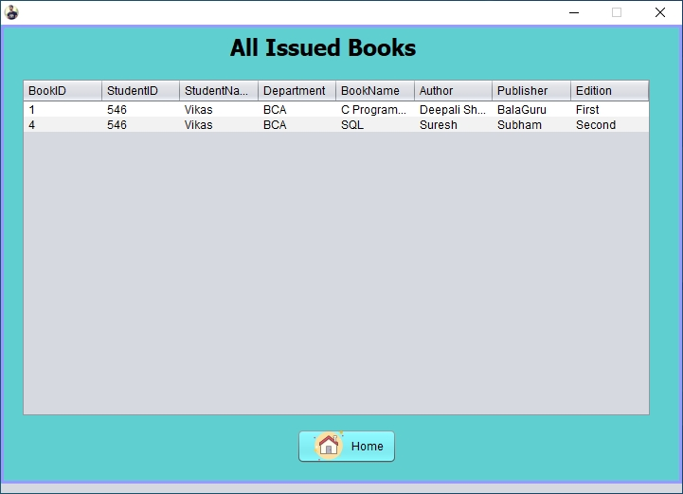
Figure 13 All Issued Books

This Form shows all books which are issued by librarian to student.

About

package Classes;

import java.awt.Color;
import java.awt.Desktop;
import java.awt.Toolkit;
import java.net.URL;
import javax.swing.JFrame;

/**
*
* @author Vijay
*/
public class About extends javax.swing.JFrame {

/**
* Creates new form History
*/
public About() {
initComponents();
setExtendedState(JFrame.MAXIMIZED_HORIZ);
setVisible(true);
setResizable(false);
setIconImage();
}

private void HomeButtonActionPerformed(java.awt.event.ActionEvent evt) {
// TODO add your handling code here:
Main m = new Main();
this.hide();
m.setVisible(true);

}

private void FbButtonActionPerformed(java.awt.event.ActionEvent evt) {
// TODO add your handling code here:
try{
Desktop.getDesktop().browse(new URL("https://www.facebook.com/pgl.vijay").toURI());
}
catch(Exception e){
}
}
private void InstaButtonActionPerformed(java.awt.event.ActionEvent evt) {
// TODO add your handling code here:
try{
Desktop.getDesktop().browse(new URL("https://www.instagram.com/vijay_pgl").toURI());
}
catch(Exception e){
}
}

private void LinkedInButtonActionPerformed(java.awt.event.ActionEvent evt) {
// TODO add your handling code here:
try{
Desktop.getDesktop().browse(new URL("https://www.linkedin.com/in/vijay-kumar-patel-1853b31b5").toURI());
}
catch(Exception e){
}
}

/**

* @param args the command line arguments
*/
public static void main(String args[]) {

java.awt.EventQueue.invokeLater(new Runnable() {
public void run() {
new About().setVisible(true);
}
});
}

// Variables declaration - do not modify
private javax.swing.JButton FbButton;
private javax.swing.JLabel HeadingAbout;
private javax.swing.JButton HomeButton;
private javax.swing.JButton InstaButton;
private javax.swing.JButton LinkedInButton;
private javax.swing.JPanel bgPanel;
private javax.swing.JPanel bgPanel1;
private javax.swing.JLabel email;
private javax.swing.JLabel intro1;
private javax.swing.JLabel intro2;
private javax.swing.JLabel intro3;
private javax.swing.JLabel intro4;
private javax.swing.JLabel intro5;
private javax.swing.JLabel name;
private javax.swing.JLabel pic;
private javax.swing.JLabel projecttitle;
// End of variables declaration

private void setIconImage() {

setIconImage(Toolkit.getDefaultToolkit().getImage(getClass().getResource("winicon.png")));
}
}

Figure 14 About page

4.2 Chapter 4 conclusion

Chapter 4 is programming chapter which include the important coding used in the system. By referring to the chapter 4, user can roughly know how the system process.

In programming stages, the problem I faced is to write some coding which I never learn before such as DrawString and DrawImage.
The coding include a lot of X and Y-axis to defined the location of the string.

The lesson I learnt in this chapter is the most difficult part of programming is not coding but logic. Each business has their owns business logic and business flo

process. We need to have clear understanding of how an organization works to create a system which desirable for them. Besides that, whenever we meet some coding difficulties, we can always seek help from Google. From this project, I knew that every coding have the sample or solution on the web. We should not keep complain that the coding is difficult but we should improve our knowledge on the logic business process.

Chapter 5
System Testing

5. System Testing

This chapter will show the test plan which programmer used to test the system. System Testing is an important phase in SDLC to ensure the system is bug free. If the system hasn’t been test properly, user will meet a lot problem when using the system.

5.1 Test Plan

Tester Name : Vijay
Module Name : Login Module
UserID : Vijay
Password : 000
Expected Result : Password do not matched.

Tester Name : Vijay
Module Name : Login Module
UserID : whoami
Password : 000
Expected Result : Username and Password do not matched.

Tester Name : Vijay
Module Name : Login Module
UserID : Vijay
Password : 123
Expected Result : Success login to system

Tester Name : Vijay
Module Name : Add Record
Test Method : Key in corret information
Expected Result : Record successful added

Tester Name : Vijay
Module Name : Add Book
Test Method : Key in corret information
Expected Result : Book successful added

Tester Name : Vijay
Module Name : Issue Book
Test Method : Key in corret information
Expected Result : Book Issued to “AAA”.

Tester Name : Vijay
Module Name : Return Book
Test Method : Key in corret information
Expected Result : Book Returned.

Tester Name : Vijay
Module Name : Delete Book
Test Method : Key in corret information
Expected Result : Book successful Deleted.

5.2 Chapter 5 Conclusion

System testing phase made me understand the important of bug free system. If one system contains bugs, users will be frustrated and meet some problems. Computerized system should be creating to help user reduce the work so it is very importance so ensure the system is bug free.

In system testing, the problem I meet is time limitation. After complete the system, I only left few day due to wasting too much time at earlier stages. With the helps of my friend, I done the module test and debug on it.

We must test the system completely and perfectly to ensure the system is bug free. No matter how powerful a system, it will not consider as good system if it contains bugs. The system which is bug free is more powerful and more helpful to end user because it does not produce problems and bugs.

Chapter 6
Conclusion

6. Conclusion

6.1 Introduction
In this final chapter, the final evaluation and conclusion will be performed on the testing and analyzing process that done in previous chapter including seminar linkage, strengths, weakness and future enhancement of the Library Management System. In addition, personal reflection also include in final part of this chapter.

6.2 Linkage to seminar
In this project development, I used Sqlite Manager because I chose Sqlite Manager as
my seminar title. During seminar research process, I found out that Sqlite is an
enhanced security features database. The seminar shows that Sqlite contains
more function compare to the previous version of SQL Server.

On the other hand, Sqlite provides authentication so that unauthorized personnel
is not able to gain access into database. I need to obtains the authentication code only can access and view the tables. In the coding part, I need to define the Server path, username and password to provide connection for Library System. This can help to enhance security and prevent unauthorized access.

6.3 Project Management Issues

During the development process of Library Management system, there are a lot issues
encountered. Firstly, I don’t have much knowledge about how library process the book
transaction and the business logic in the library. Thus, a lot research has been done to refer and to get more understanding about the library management.
On the other hand, I met problem of constructing the DFD and ERD due to the less
understanding of the diagram such as entity and relationship. With the help of Diploma

studies materials, finally I successful construct the ERD and DFD diagrams.

Finally, the biggest problem I met is the documentation format. Although I have been
provided with the document guidelines, but the instruction and guide is too much to follow especially the Reference part.

6.4 Suggestion for Future Enhancement

For future enhancement, there are few suggestions to improve the system abilities. Firstly, the library system should implement smart card technology which will log in the member by scanning the smart card. The smart card can act as a unique identifier of a member. The smart card technology is more advanced and is able to store all the information inside the chips. By implements this, the book transaction process will be enhanced and save time.

Next, the wide screen monitor is getting more popular day by day. Library Management System should able to support the wide screen resolution such as 1152 x 648 or 1280 x 720 so that user can view the system in perfect view.

More information can be inserted into book table such as product version, type of product (magazine, encyclopedia or newspaper) to enhance the system to be more perfect. In addition, the system should be enhanced so that one book can have more than one author. Currently the system only supports one author per book. Some book is having more than one author and user may miss to search the book.

Currently, the reservation made cannot be detected without restart the system. The system should be enhance so that the data can be updated in short time or pressing a button to avoid any error.

6.5 Personal Reflection

In this project development process, I have learnt a lot of new knowledge and programming code from this project. Besides that, there are also some problems that appears as biggest challenge during the development process.

During system design stages, the problem appears on how to construct the Entity-
Relationship diagram and Data Flow Diagram. Assignments and studies materials in
Diploma level studies materials are referred back. Some sample diagram and researches are done via Internet for more reference.

On the other hand, the biggest harvest gained through this project development process is the importance of communication between teammates. The communication is very important because there must be integration between 2 teammate’s systems. In this project, I do library system and my friend do library web site. We share one database server and so that we must communicate at early stage so that there is no crash when integration. In addition, discussion is needed in developing the project to match among library system and library web site. A good communication is needed to avoid unnecessary problems appear and delay the completion time.

Chapter 7
Appendices

Appendices

Setup Project Environment

To execute this system, user must first setting up some project environment. Firstly,
user must create a folder named ‘Pictures’ located in C:\. This folder is used to store
the photo used in the system such as book cover or member photo.

Installation Guide

1. Double click on a LibraryManagementSystem.
2. Click Next
3. Select the installation path
4. Click Next twice to proceed to installation process.
5. After complete installation, click Close to exit the installation.
6. The Library system is now available to use at desktop.

Appendix I : Project Specification
A. Company Background

This system is developed for common library. We created the system which suits small size library. Most of the function we refer to other library system.

B. Project Objectives

The purpose we creating this project are to let common library have an electronic library management system. A lot small size library was using paper-based management system. But followed by the increase of visitors and member, librarian was suffered because there are a lot of records. When need to search for particular member record, the librarian need a lot of time.

In addition, they are suffered from a lot paper-based problem such as lost of member’s
record. Some record was missing because they failed to take good care of it. For example, the librarians forget to put back the record into cupboard when they are busy. Since my last visit to that library, I found that they need a computer management system so I think of this idea to developing a system for small size library. This is to avoid some paper-based problem such as lost of record and etc.

With the library system, librarians are able to record all the new books and new
transactions. We implement the use of bar code in this project so that librarian can process the book transaction faster when a lot of members want to make a transaction. They can save a lot of time without writing the book id.

C. Project Scope

1. Security Module
In this module, the user need to login so that able to our system:-

2. Member Maintenance Module
This module allows users to:-
▪ Add register a new Student.
▪ Add a new Book.
▪ Issue Book to Student.
▪ Return book from Student.
▪ Delete Book From database.
▪ Delete Student Record from database.
▪ Update Student information.
▪ Update Book Information.
▪ View and search book.
▪ View and search student record.

Non-functional Requirements
i) Product Requirements
a) Efficiency requirements
With the library management system, librarian should be able to process faster
when they process book transaction. In addition, with the use of bar code scanner,
librarian can avoid to type the book id one by one, bar code scanner enable
librarian to scan the book id instantly.

b) Reliability requirements
The system must perform accurately towards member request. For example, when
the librarian saves the edited profile detail, after they review their detail, the details

must be change according to the latest details that they have updated. When
member return the book after the expired date, the fine should be calculate
accurately. Besides that, in the registration form, it will have validity check to check
the input to prevent wrong data type.

c)Usability requirements
This system must be designed with user-friendly and easy to use by the staff so that
the user can perform their job nicely. It must have a clear instruction to guide user
through the system. Besides that, the description of error message should be clear.

ii) Organizational Requirements
a) Implementation requirements
In implementing the system, it uses the vb.net as the main programming
language and tools. Besides that, the SQL language will be use to maintain the
information in the database. On the other hand, SQL Server 2008 needs to be
installed.

b) Delivery requirements
The whole system is estimate to be done around 6 months time and the
documentation will be done in 2 months. The full system will be delivers in a
softcopy method while the documentation will be delivers in hardcopy and
softcopy.

iii) External Requirements
a) Legislative requirements
The information that use must be acknowledge by the authorized people so that
it has no violating the law. This information is copyrighted and protected by the
law. Besides that, when visitors wants to become the member of the library, he
or she must agree with the rules stated in the system.

b) Security requirements
This system must be highly secure in the login part. It is because the report can
only view by admin level. Staff can perform most of the process except viewing
report module and log file module.

D. General Description
This section generally describes the overall system’s functionalities and other
information.

a) Product Functions
Library Management system was creates for the small library. The product was
developed to let the librarian have electronic management system to replace
paper-
based system. The part I will describe here is offline system.
The main function of this library management system is to let librarian perform
their work with more efficiency and effectively.

b) Similar System Information
The type of library management system is quite similar with the existing library
system used by Library Vijay Kumar Patel. After compare the system
requirements with their system, I found that our system have 80% similar to
them.

c) User Problem Statement
Currently, the library was using paper-based system. According to the librarian,
they will lost the member’s record sometimes because of too busy. When they
busy to handle book transaction process, they will accidentally lost the record.
Besides that, they need to calculate the fine manually. For example, the user
return the book after expired date, currently the librarian need to check how
many days has passed after expired date and then multiply with RM0.50 the
process is all done manually and it is waste of time.

d) Users Objectives
Nowadays, the visitors are increase day by day. The librarian needs library
management systems which can easier their job efficiently and effectively. The
library management system should able to process book transaction process and
also register new member, staff and book

e) General Constraints
i) Lack of time to complete the Final Year Project
The estimated duration to complete this project is about 8 month, and we are
busy with industrial training. The time is very limited and still we need to
determine the time to:
• Plan how the system works
• Review and analyze the requirement on the system
• Designed the system based on the project specification
• Code the program up with the complete documentation
• Having system testing
• Implement the system

E. External Interface Requirements

a) User Interface
For the user interface, the system will contain the standard Graphic User
Interface (GUI) which is:
• It will be created to be full screen so that user can view the system clearly.
• The background colour will not be too bright because too bright will cause
user’s eye not comfortable.
• The background colour for the entire page in the system will be consistent.
• When customer login into the system, his or her name will appear in top right
corner of the main page following by the current time and “logout” word.
• The size of the button will be standard in some size to avoid customer
confusion.
• The button label would be easier to understand. For example, delete a record
using “Delete” button but not “Destroy” or “Drop”.

b) Hardware Interface
• This system can use in any type of computer such as personal computer and
laptop.

c) Software Interface
i) The operating system that the customers need to use Library Management
System is Window XP and Window Vista.
ii) Sqlite Manager is needed to work as a database server.

d) Communication Interface
1. Library Management system that we developed is a main interface that allows
communication between users and the system.

F. Development Environment
In developing Library Management System, we will need to use some hardware, software tools, and other resources such as programming languages.

• Hardware
The hardware that use to develop the project include standard personal computer.
It is the basic requirement for developing the Library Management System. In
addition, bar code reader is also compulsory to make the process more efficiency
and reliability. User may not accidentally key in wrong information when make a
book transaction.

• Software tools
The following is the software and tools that use to develop the project because
these can help the project to be build.
i) NetBeans IDE 12.3
- This software can use to design the system’s interface. Besides that, we can
write some coding to allow the button functioning. After developed the
system, we can generate the installer to let user install the system.

ii) SQL Server 2008
- The SQL server 2008 will act as the database server in our system.

• Programming language
Programming language that use includes Java to develop the library system
through NetBeans software. While for the database, SQL language uses to
maintain the database. The reason we choose to use these programming
language is because these language is being teach before and I am familiar with
it.

